Date 22-01-2024

**Creating vm and ssh vm**

1. **Resource group**

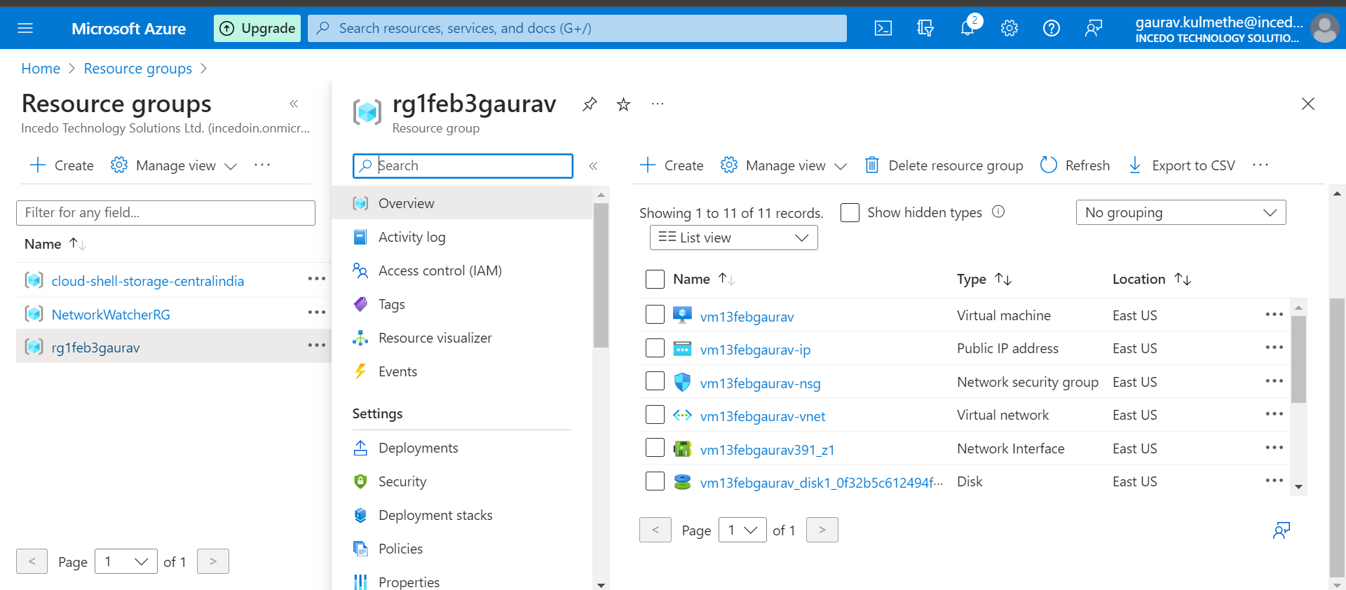

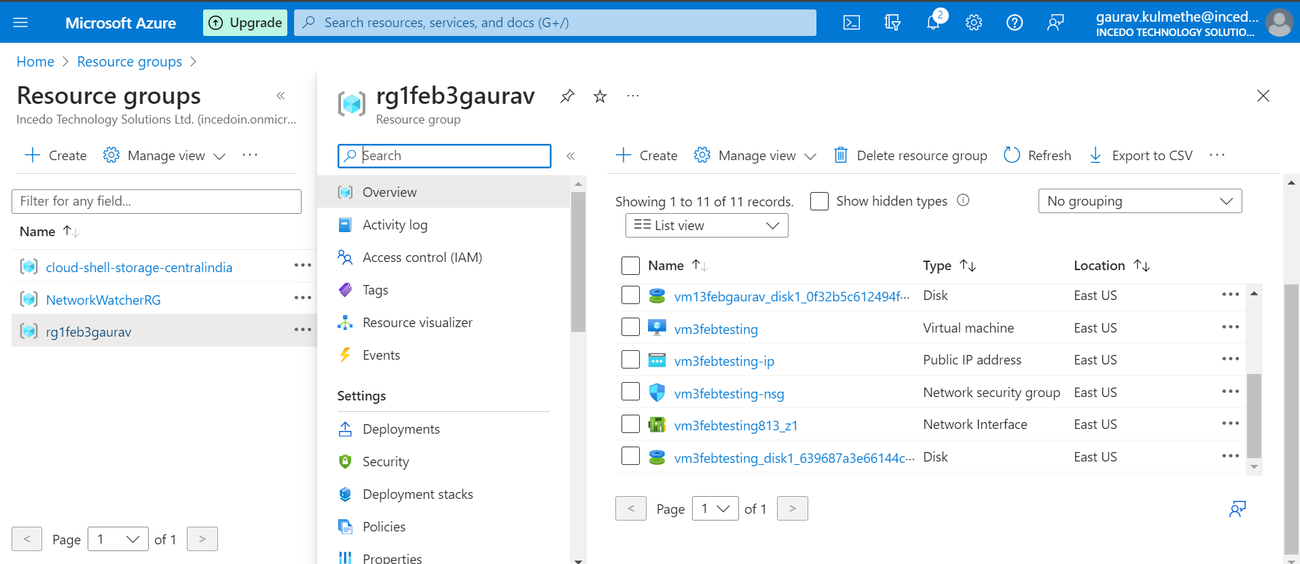

1. **1st vm machine**

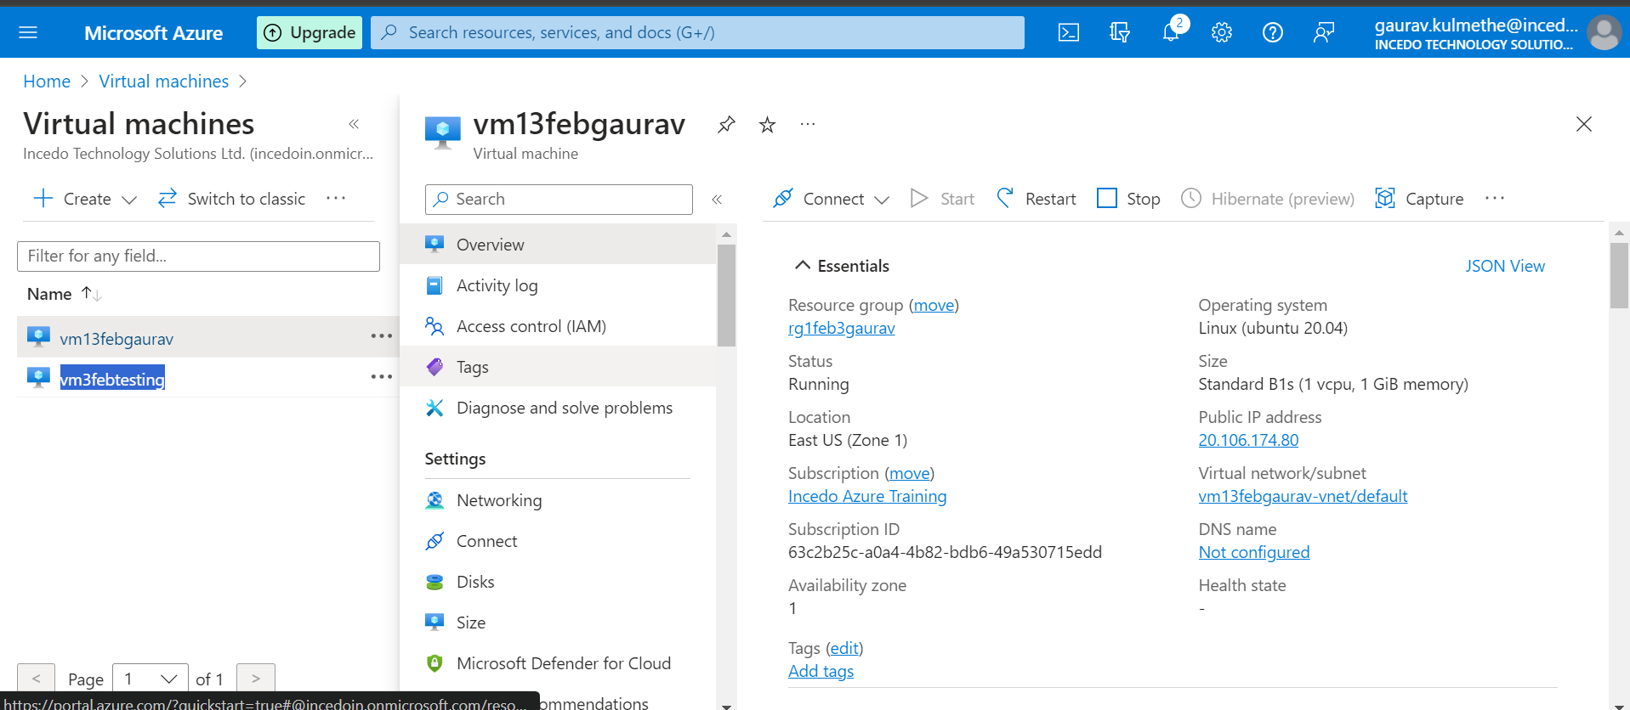

1. 2nd vm machine

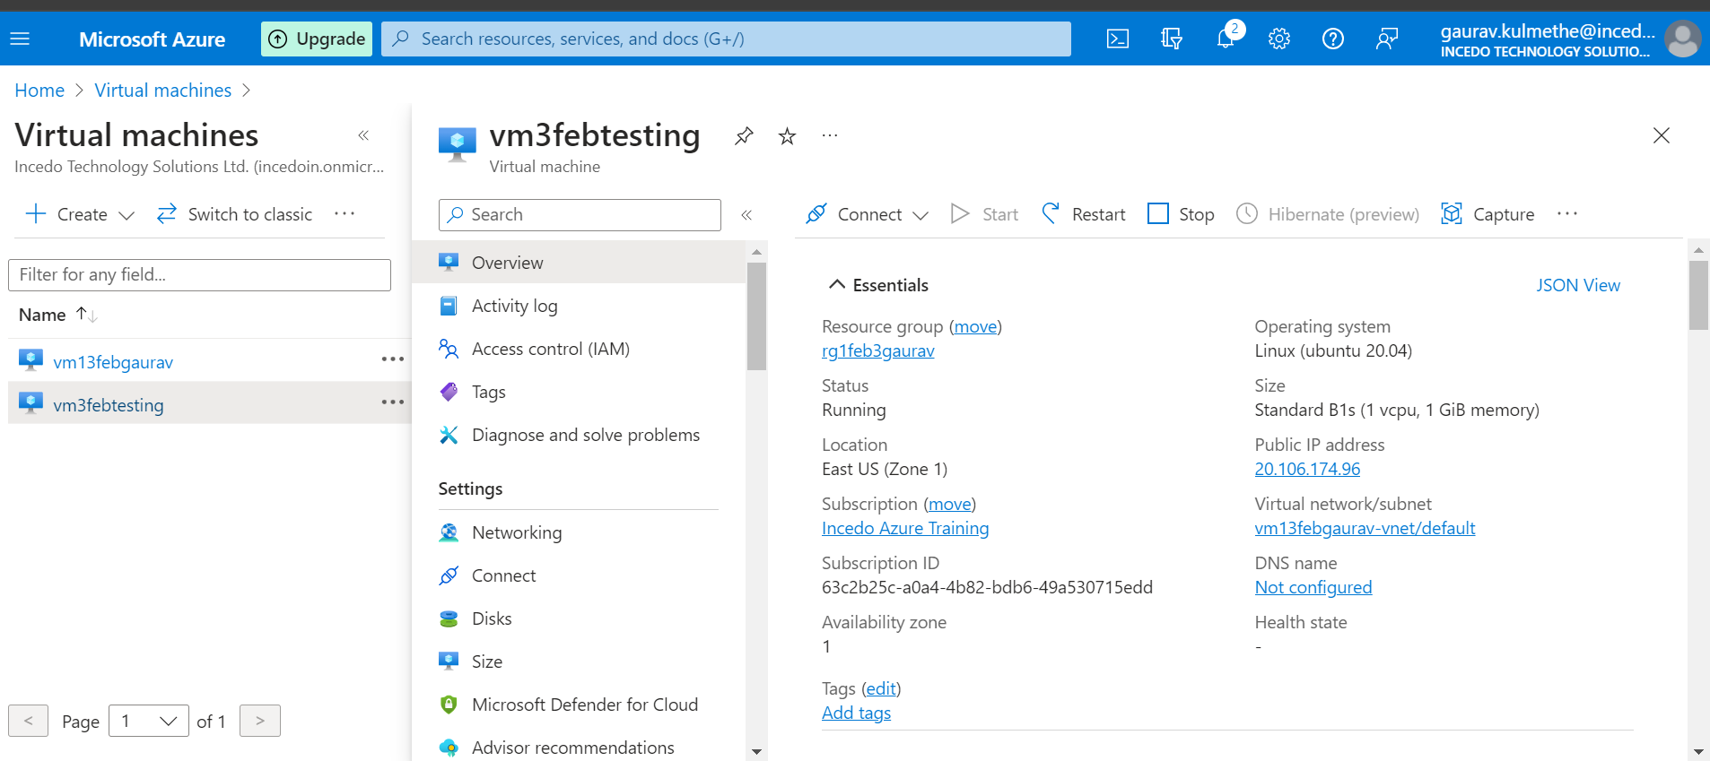

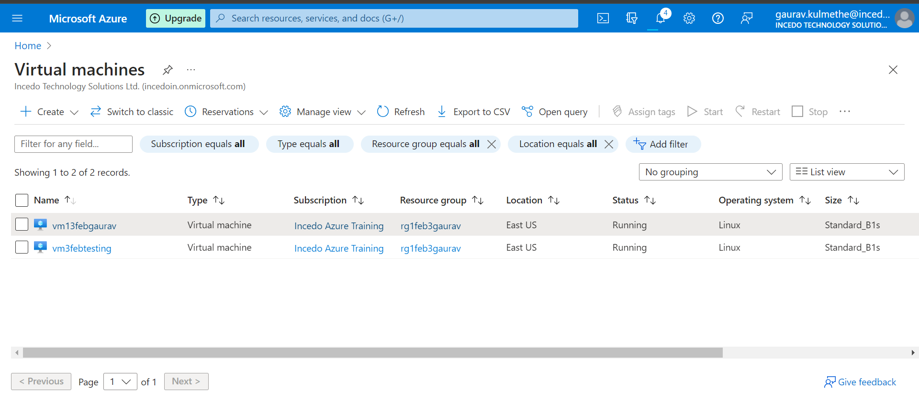

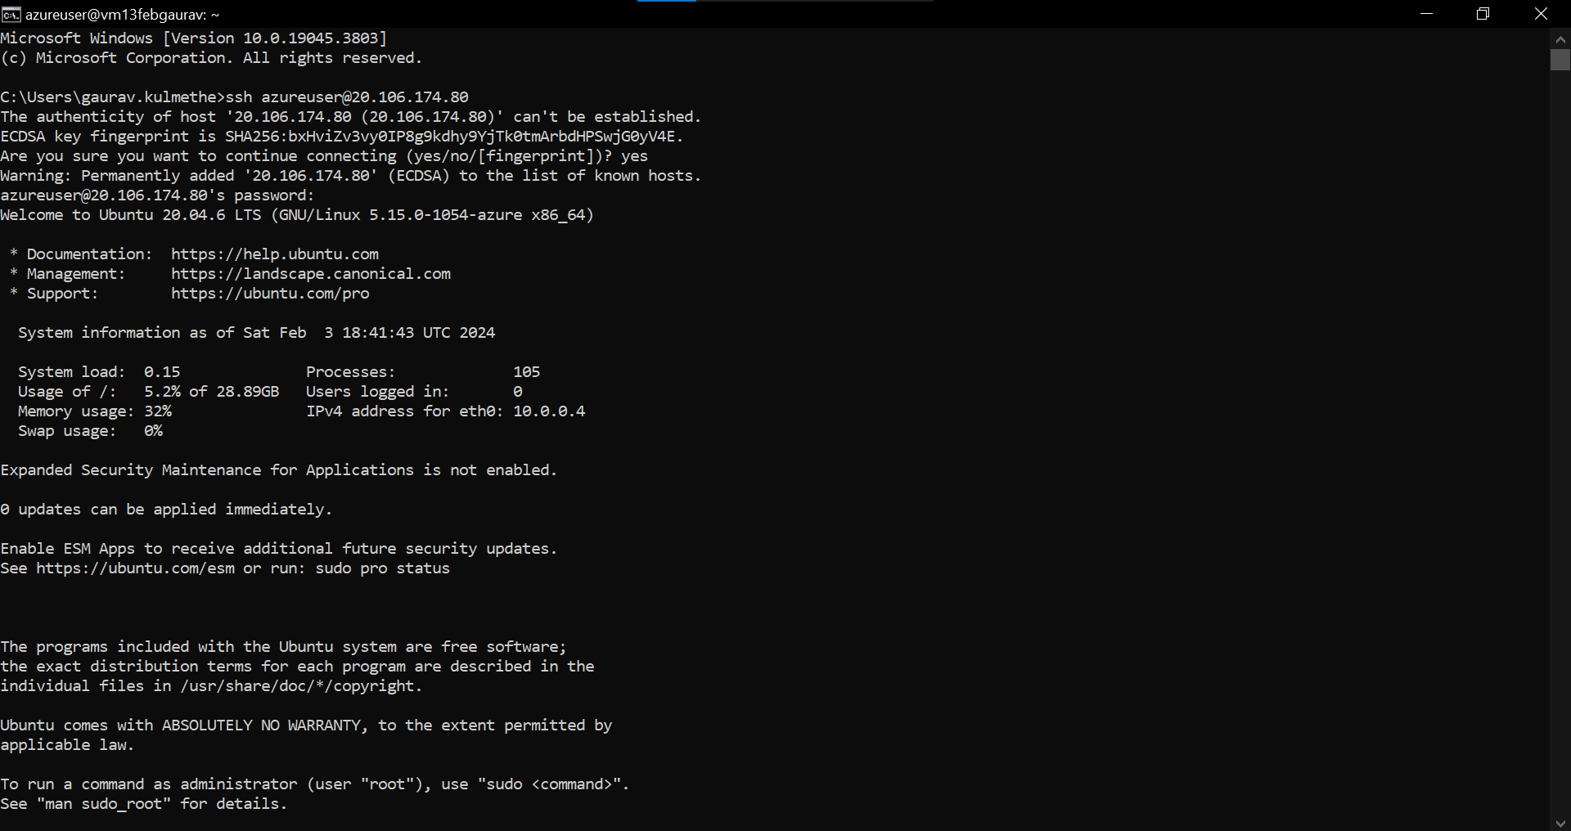

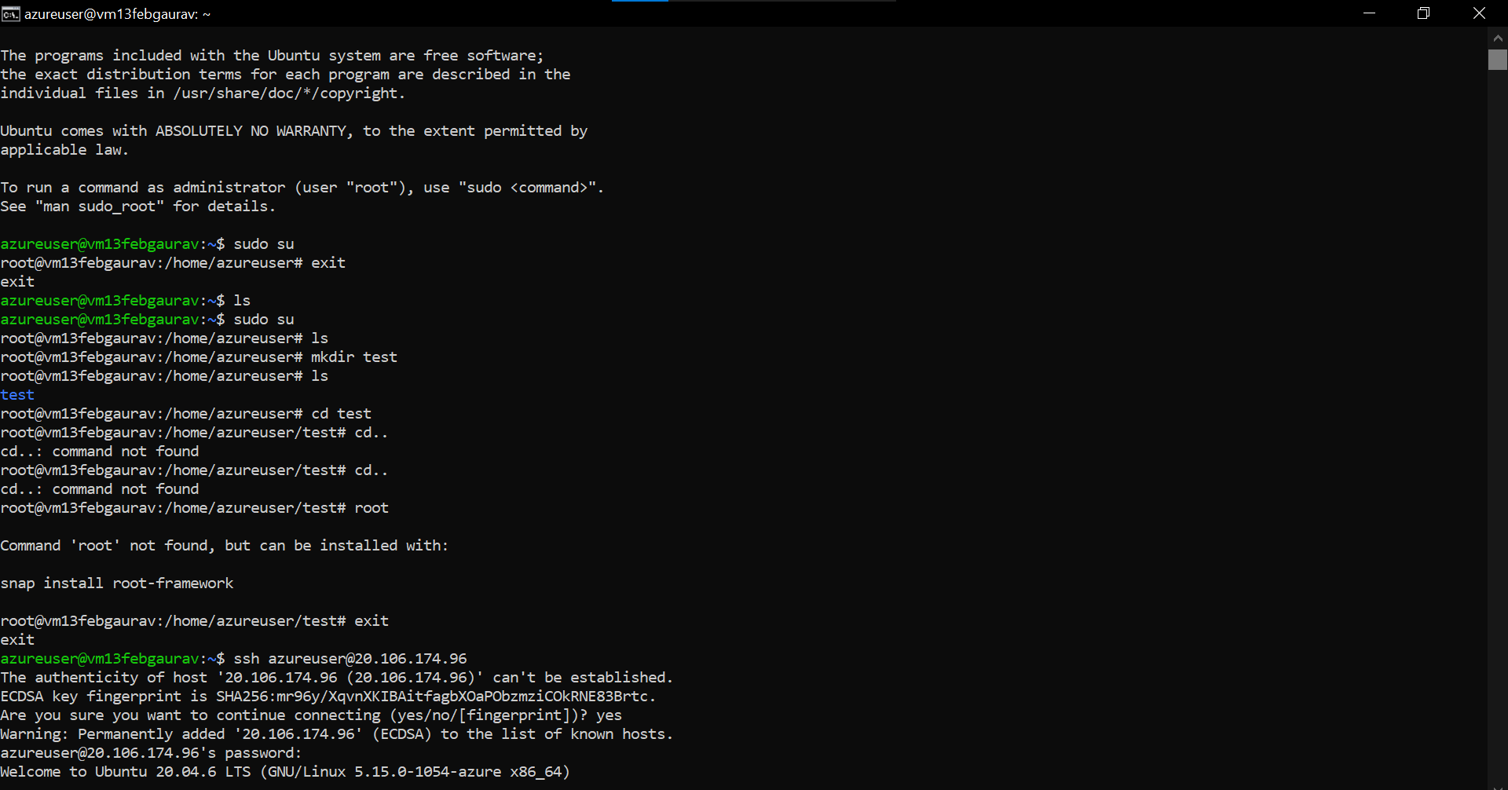

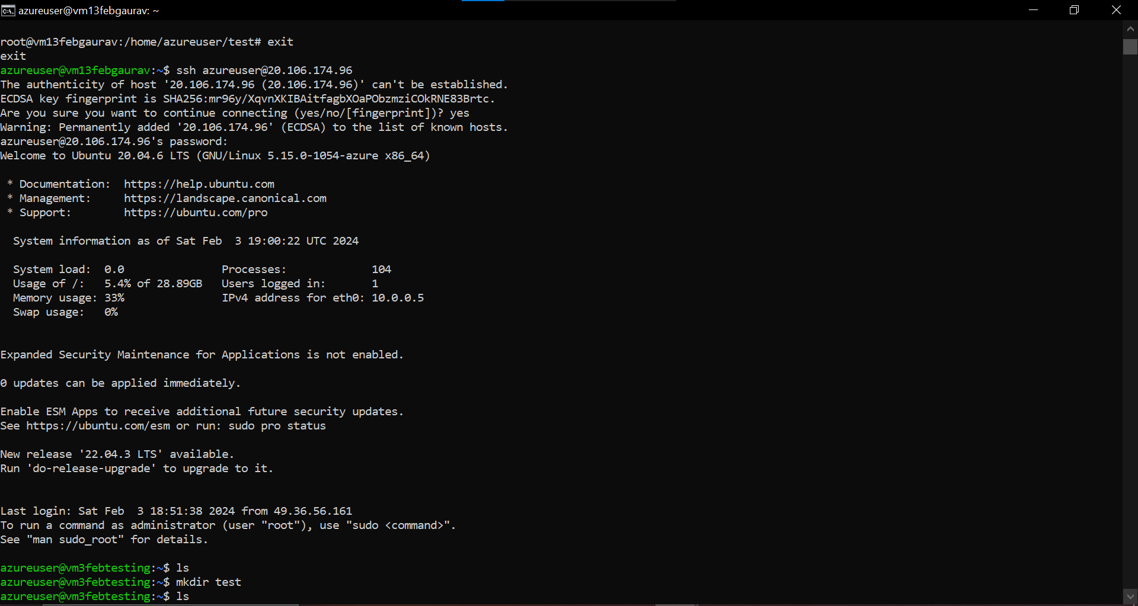

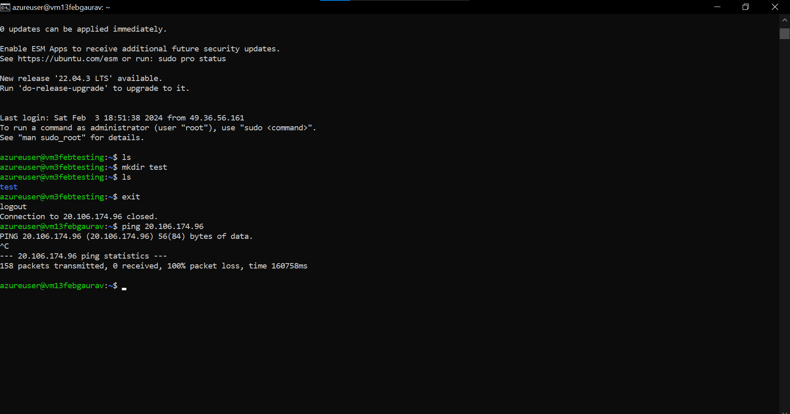

1. 2nd vm testing

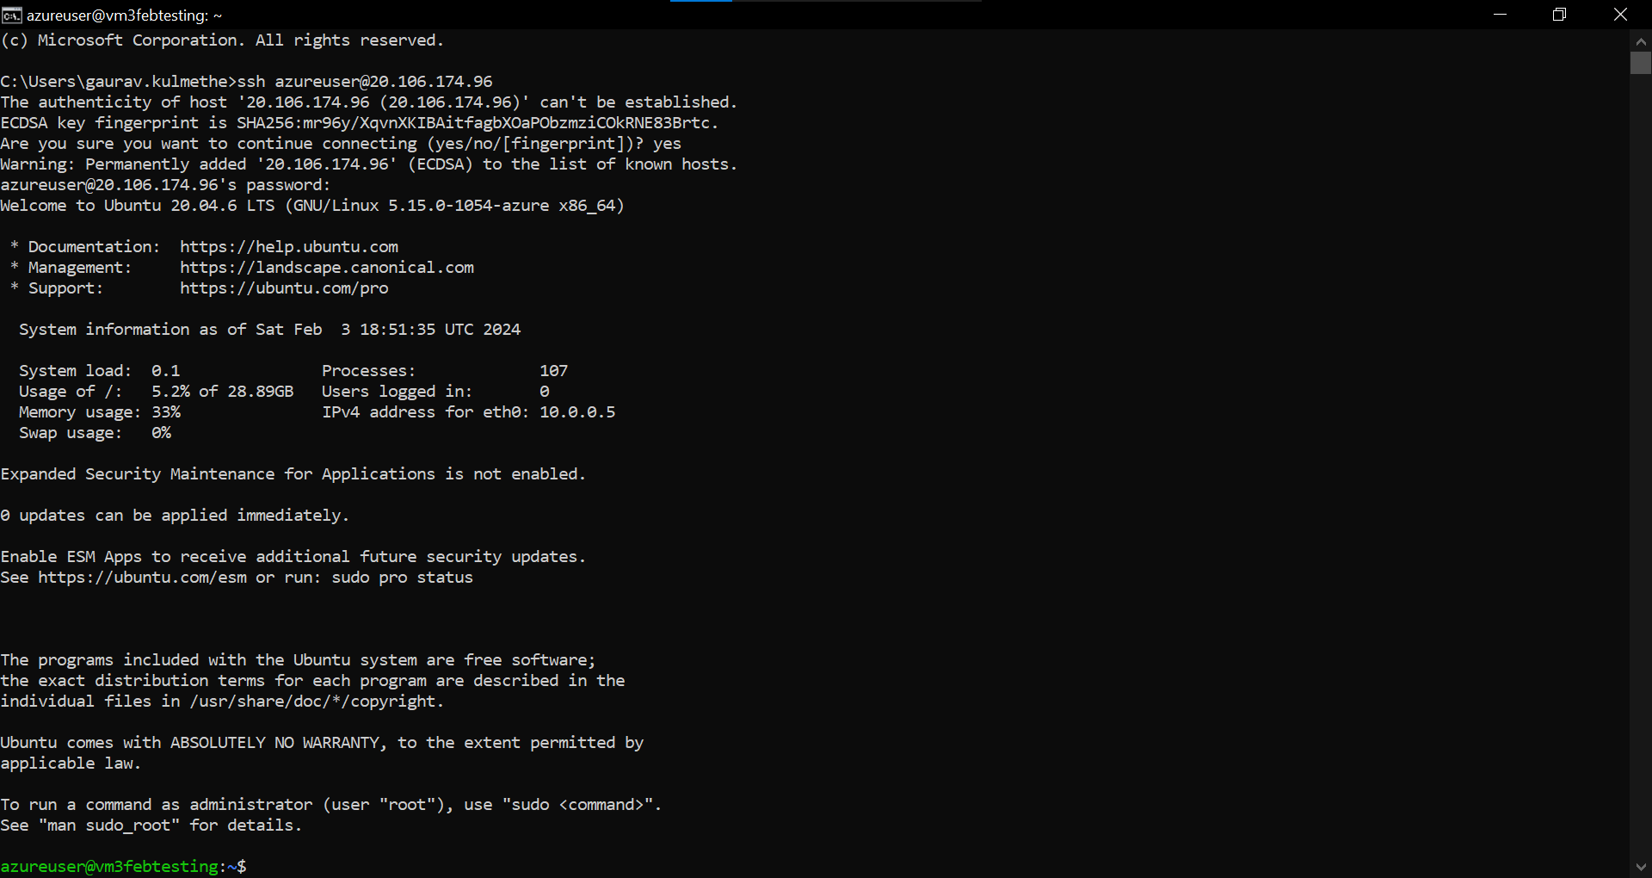

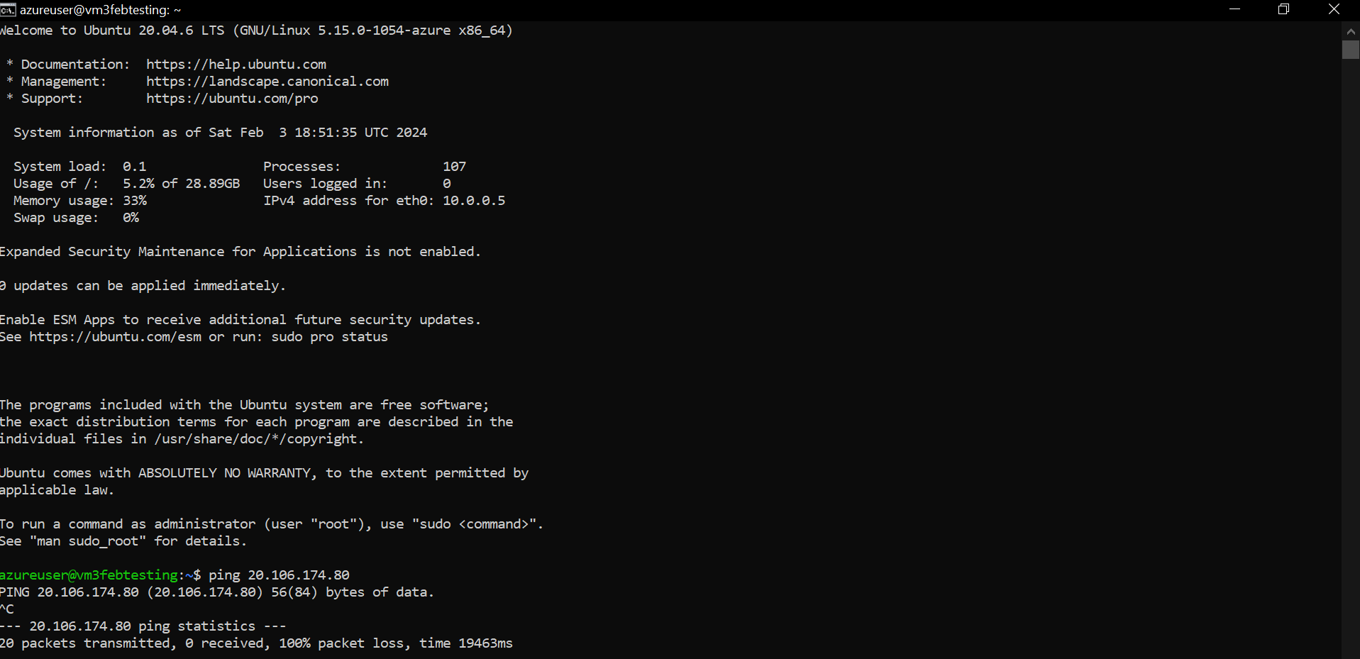

Date 23-01-2024

**Task – Create database and database server and connect with the dbeaver**

Date 24-01-2024  
  
**Task - Data containerization in cloud**  
  
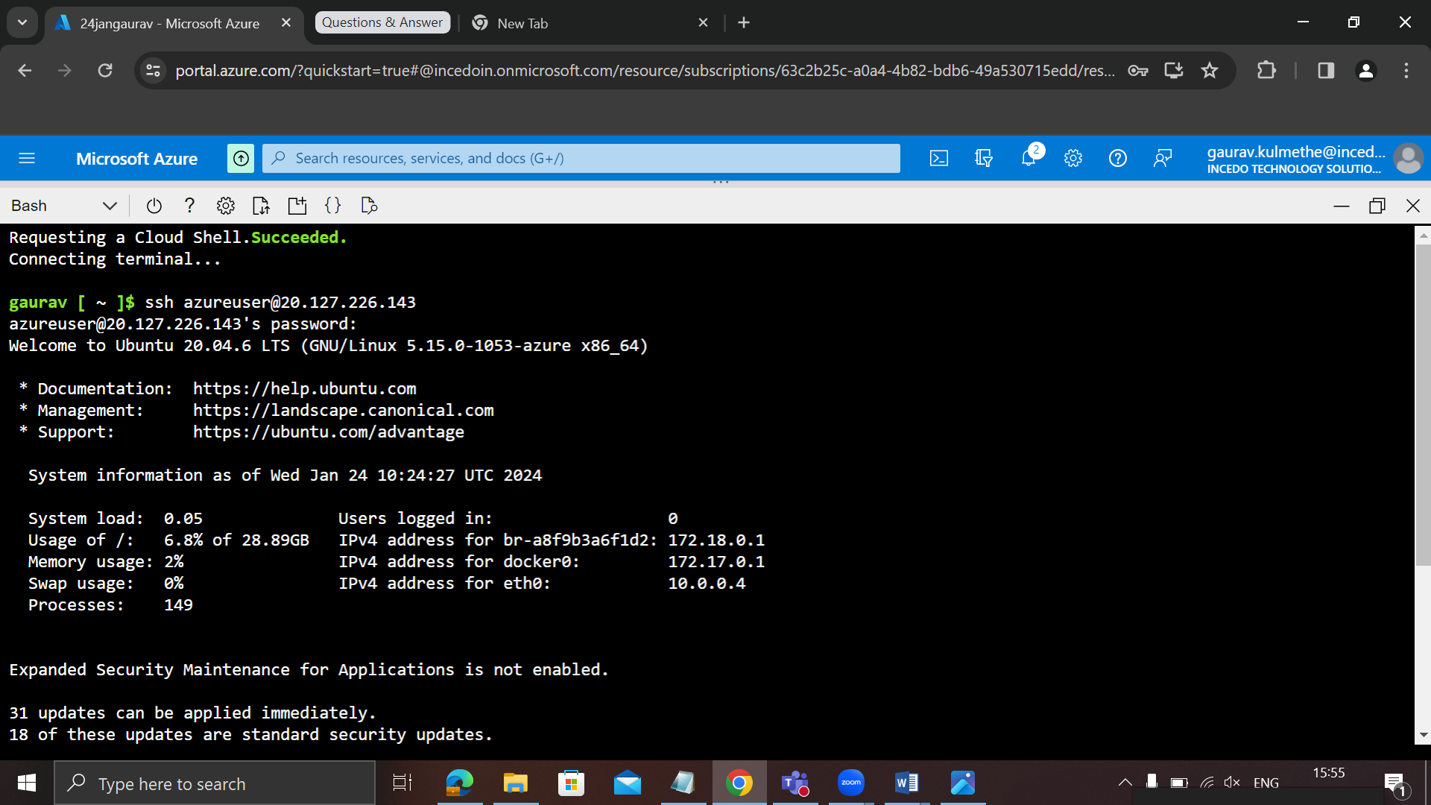

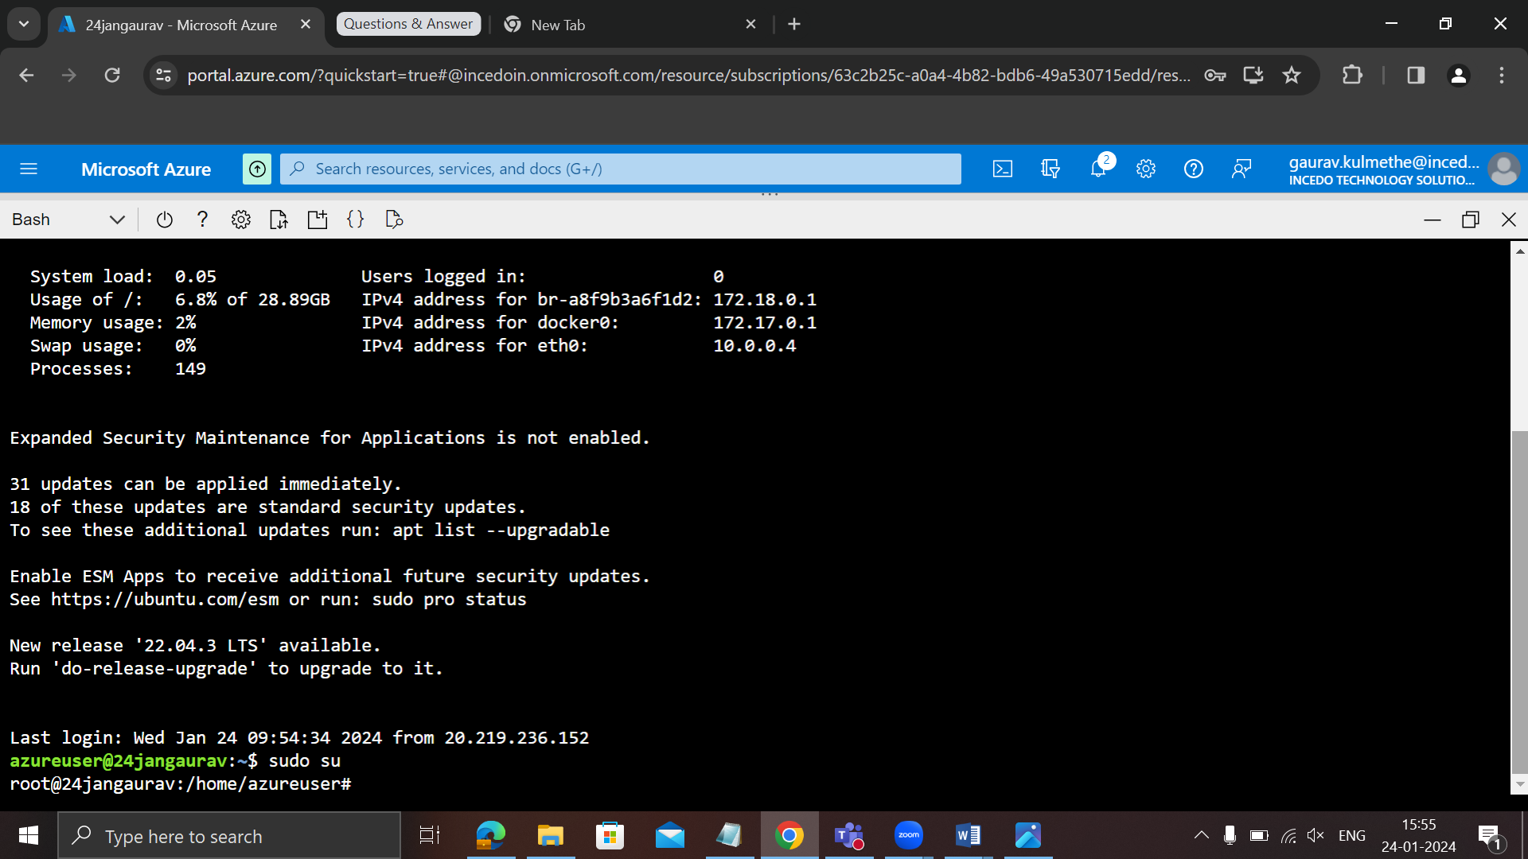

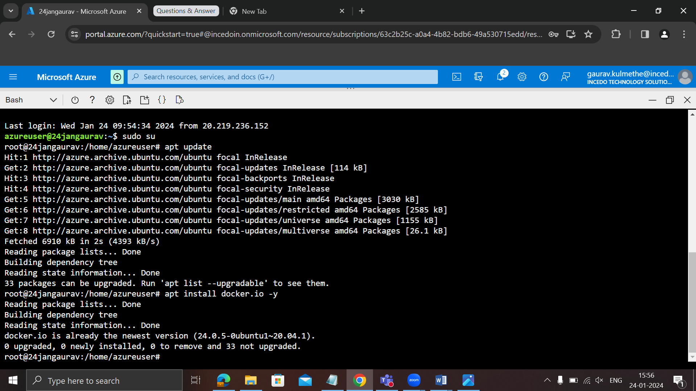

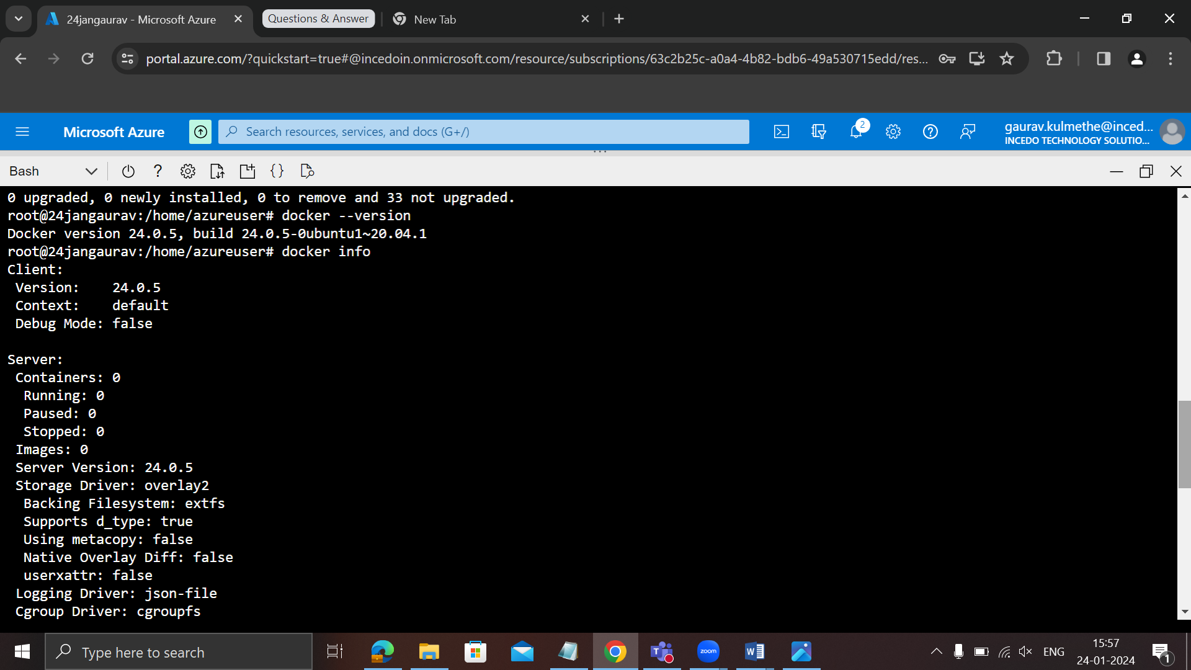

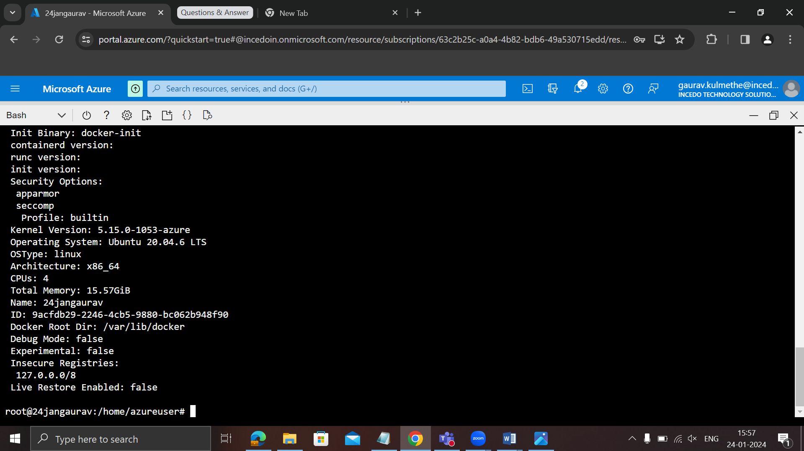

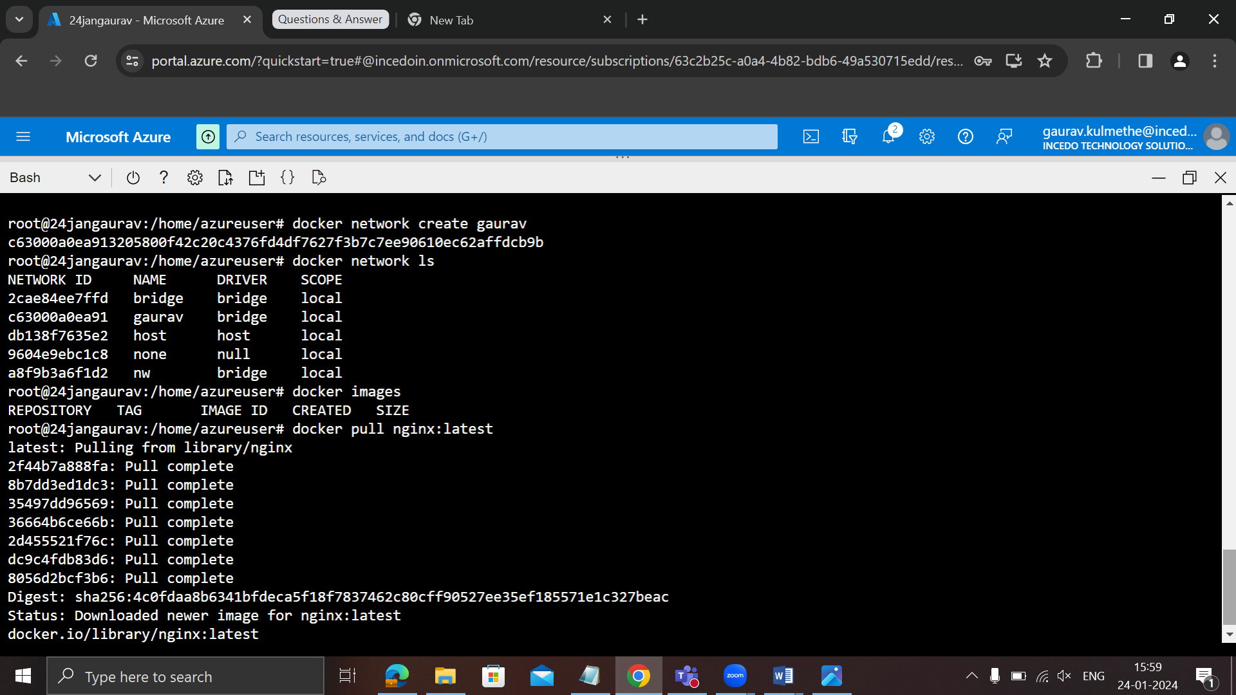

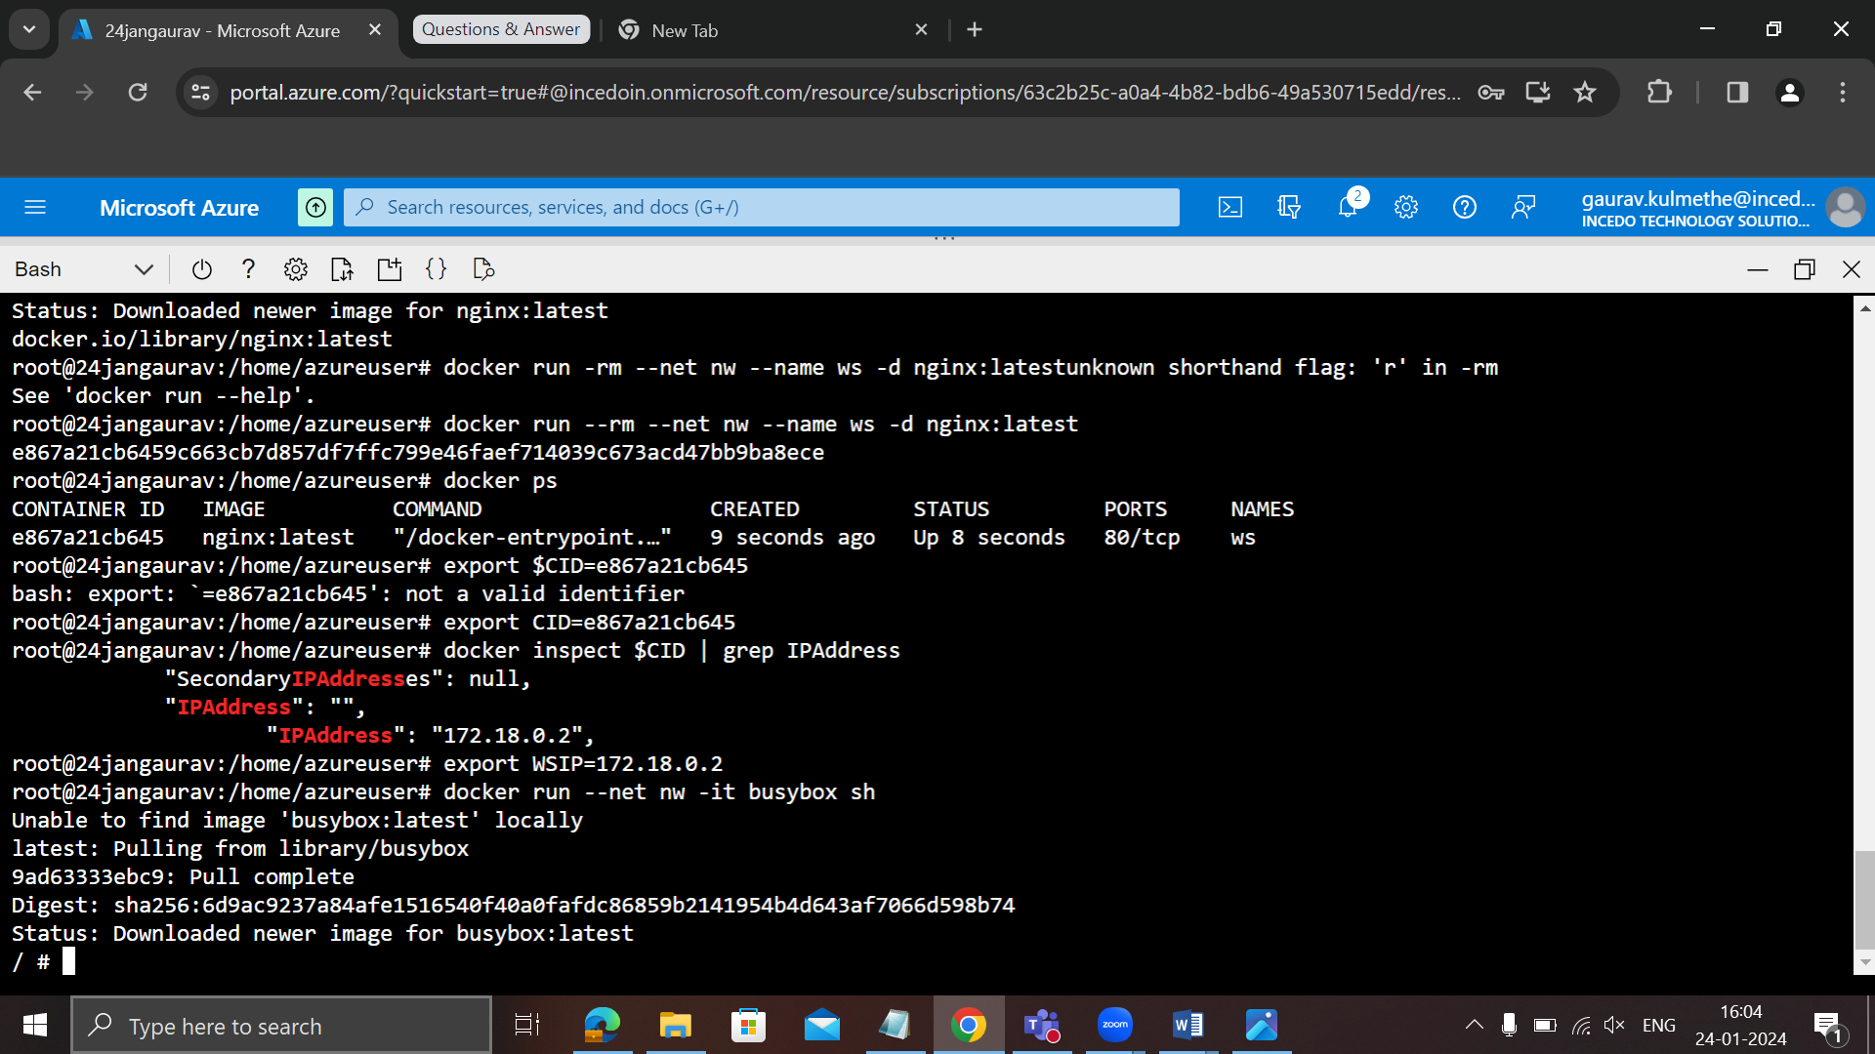

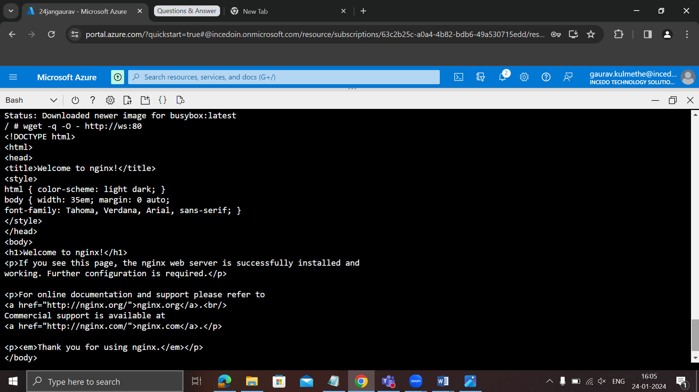

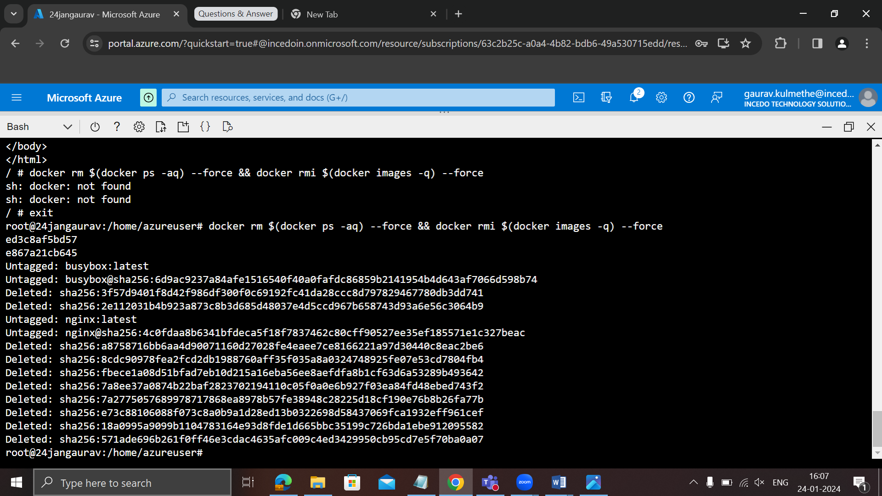

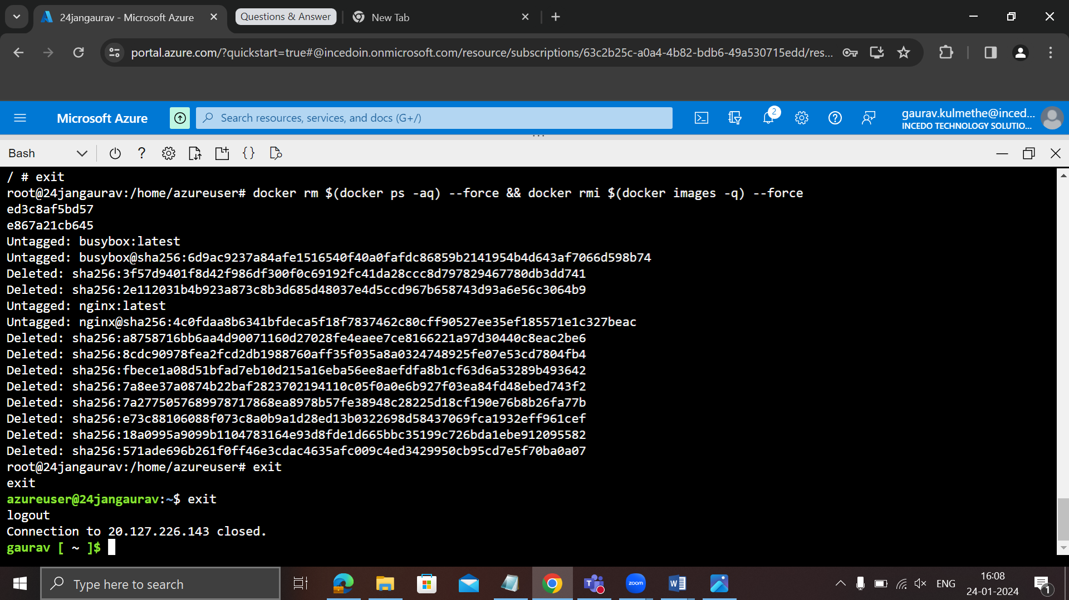

Azure load balancer dt. 29-01-2024

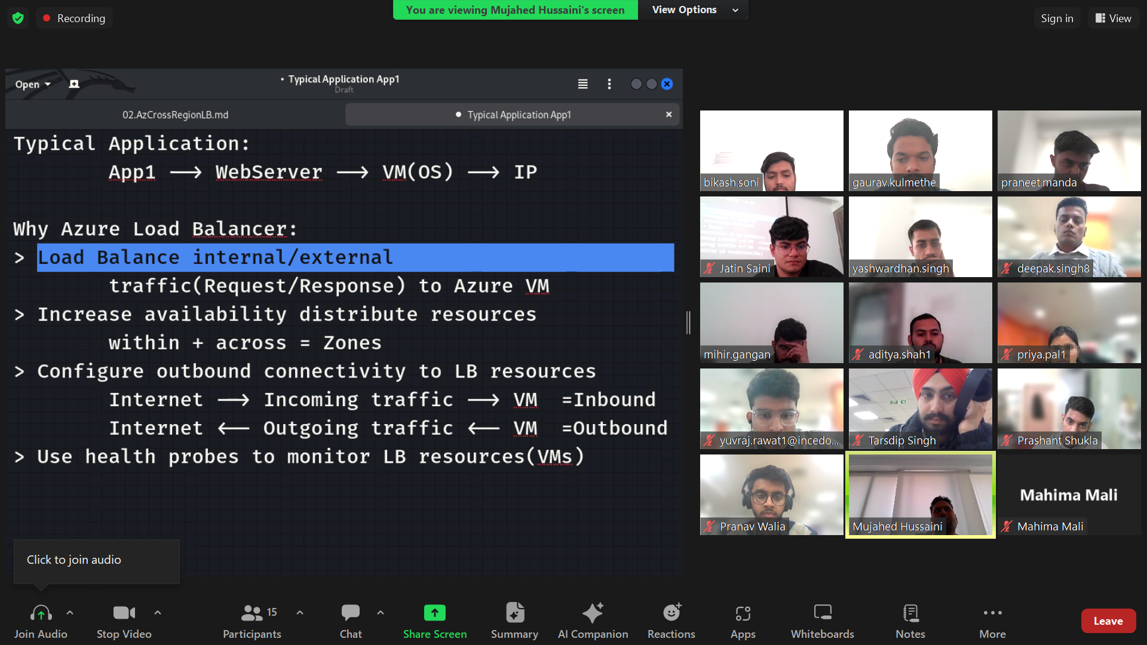

Inbound traffic –incoming traffic  
outbound traffic – outgoing traffic

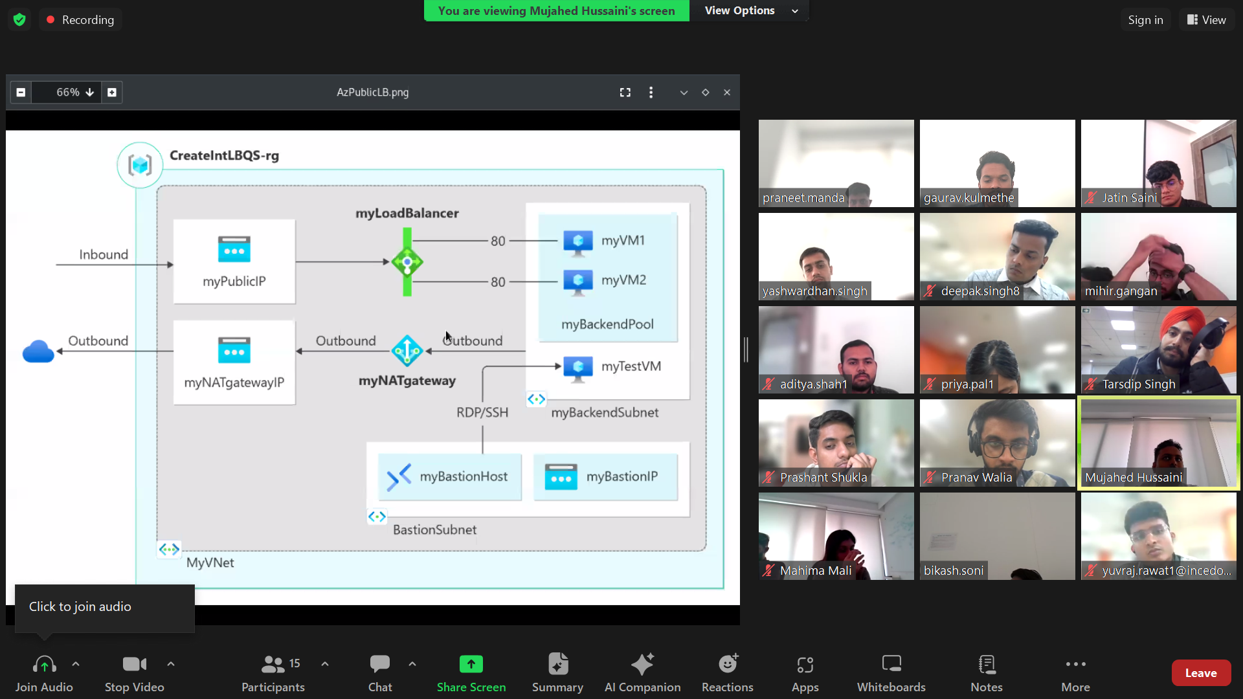

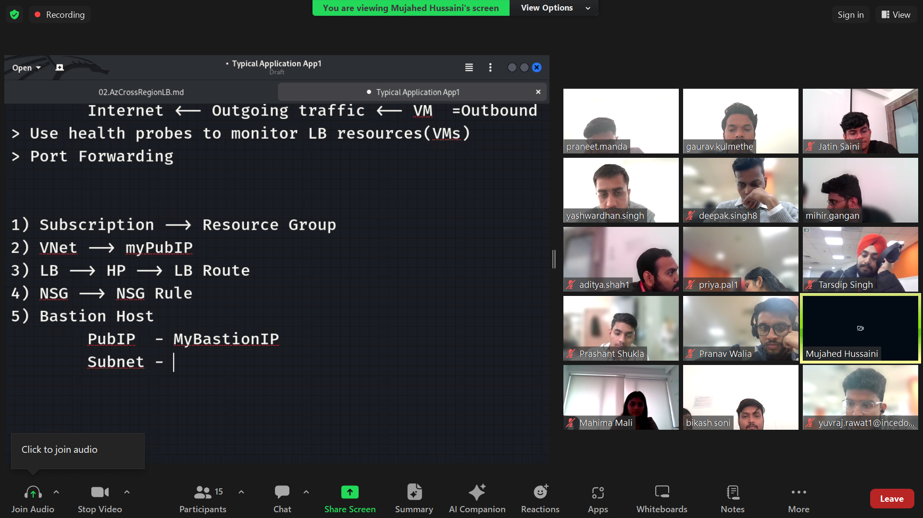

NAT – use for complete network

NIC – use for within the virtual machine

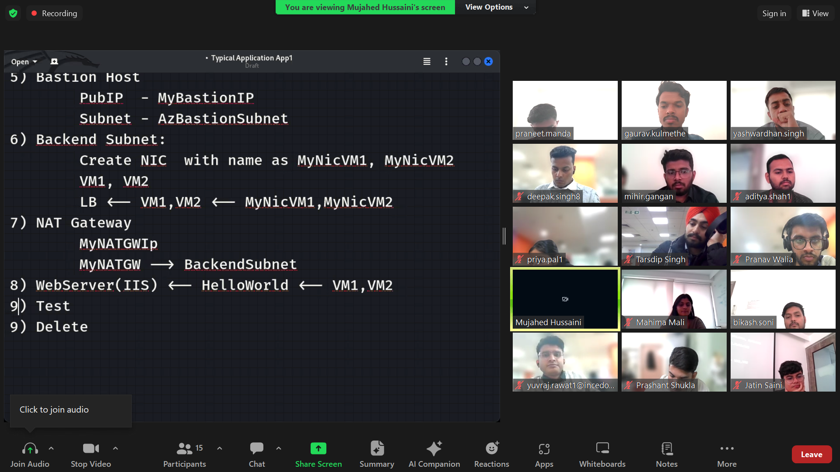

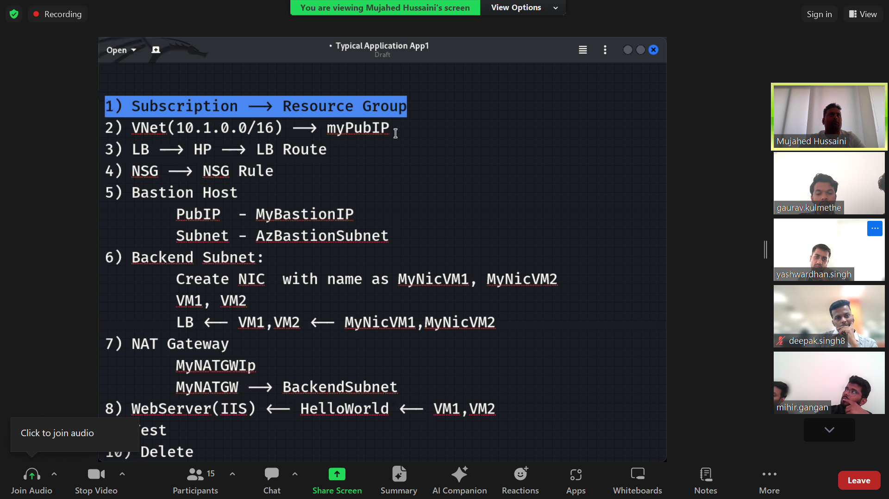

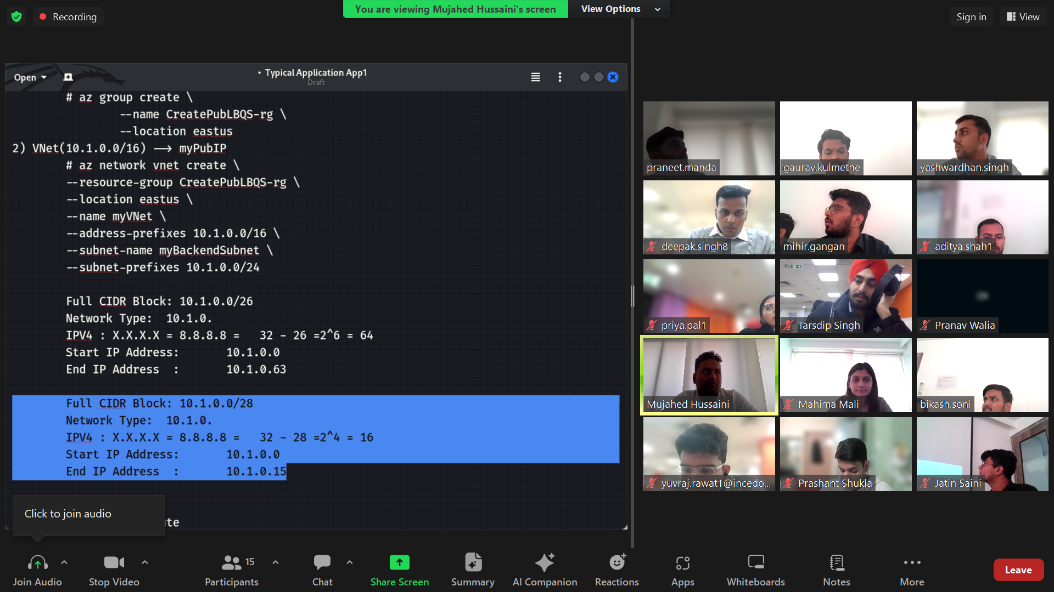

Health probe didn’t work on port number 443 https due to security concern

az network lb create \

--resource-group CreatePubLBQS-rg \

--name mylbgaurav \

--sku Standard \

--public-ip-address myPublicIP \

--frontend-ip-name myFrontEnd \

--backend-pool-name myBackEndPool

az network lb probe create \

--resource-group CreatePubLBQS-rg \

--lb-name mylbgaurav\

--name myHealthProbe \

--protocol tcp \

--port 80

az network lb rule create \

--resource-group CreatePubLBQS-rg \

--lb-name mylbgaurav \

--name myHTTPRule \

--protocol tcp --frontend-port 80 \

--backend-port 80 \

--frontend-ip-name myFrontEnd \

--backend-pool-name myBackEndPool \

--probe-name myHealthProbe \

--disable-outbound-snat true \

--idle-timeout 15 --enable-tcp-reset true

az network public-ip create --resource-group CreatePubLBQS-rg --name myBastionIP --sku Standard --zone 1 2 3

az network vnet subnet create \

--resource-group CreatePubLBQS-rg \

--name AzureBastionSubnet \

--vnet-name myVNet \

--address-prefixes 10.1.1.0/27

az network bastion create \

--resource-group CreatePubLBQS-rg \

--name myBastionHost \

--public-ip-address myBastionIP \

--vnet-name myVNet \

--location eastus

Admin password – Localhost@1234567

array=(myNicVM1 myNicVM2)

for vmnic in "${array[@]}"

do

az network nic create \

--resource-group CreatePubLBQS-rg \

--name $vmnic \

--vnet-name myVNet \

--subnet myBackEndSubnet \

--network-security-group myNSG

done

az vm create \

--resource-group CreatePubLBQS-rg \

--name myVM1 \

--nics myNicVM1 \

--image win2019datacenter \

--admin-username azureuser \

--zone 1 --no-wait  
  
  
az vm create \

--resource-group CreatePubLBQS-rg \

--name myVM2 \

--nics myNicVM2 \

--image win2019datacenter \

--admin-username azureuser \

--zone 2 --no-wait

array=(myNicVM1 myNicVM2)

for vmnic in "${array[@]}"

do

az network nic ip-config address-pool add \

--address-pool myBackendPool \

--ip-config-name ipconfig1 \

--nic-name $vmnic \

--resource-group CreatePubLBQS-rg \

--lb-name myLBMujahed

done

az network public-ip create \

--resource-group CreatePubLBQS-rg \

--name myNATgatewayIP \

--sku Standard \

--zone 1 2 3  
  
az network nat gateway create \  
    --resource-group CreatePubLBQS-rg \  
    --name myNATgateway \  
    --public-ip-addresses myNATgatewayIP \  
    --idle-timeout 10

az network vnet subnet update \  
        --resource-group CreatePubLBQS-rg \  
        --vnet-name myVNet \  
        --name myBackendSubnet \  
        --nat-gateway myNATgateway

array=(myVM1 myVM2)  
    for vm in "${array[@]}"  
    do  
        az vm extension set \  
            --publisher Microsoft.Compute \  
            --version 1.8 --name CustomScriptExtension \  
            --vm-name $vm --resource-group CreatePubLBQS-rg \  
            --settings '{"commandToExecute":"powershell Add-WindowsFeature Web-Server; powershell Add-Content -Path \"C:\\inetpub\\wwwroot\\Default.htm\" -Value $($env:computername)"}'  
    done  
  
change name of default to your name eg Gaurav  
  
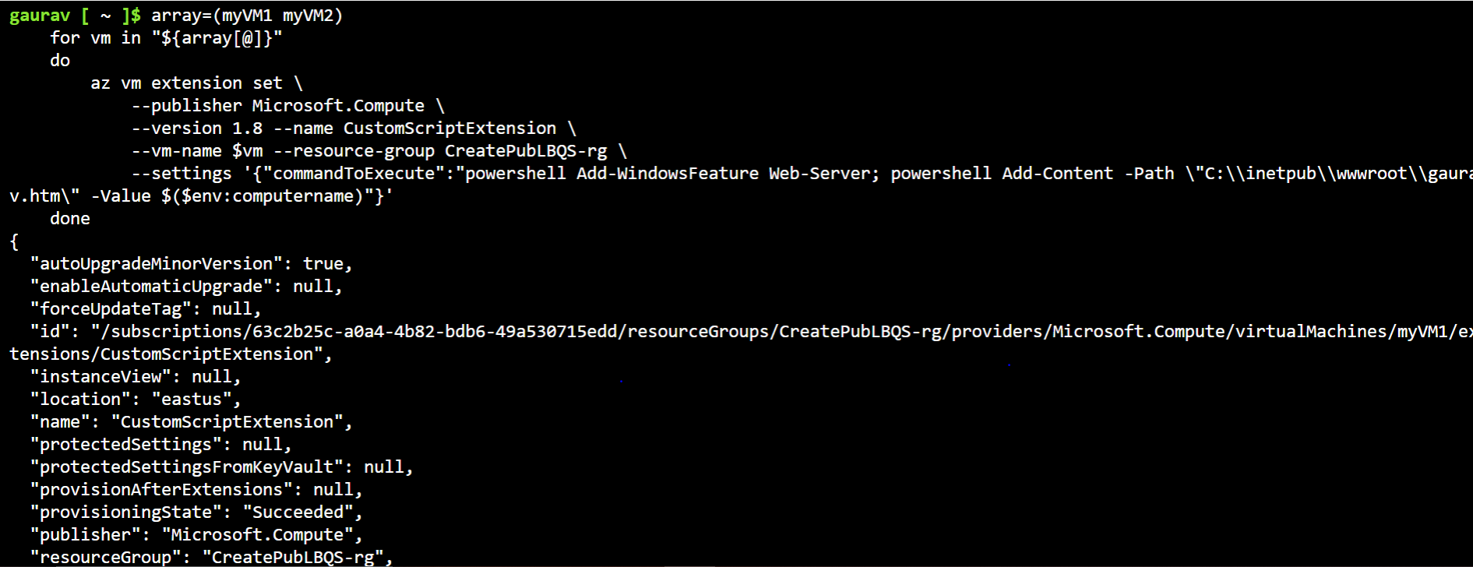  
  




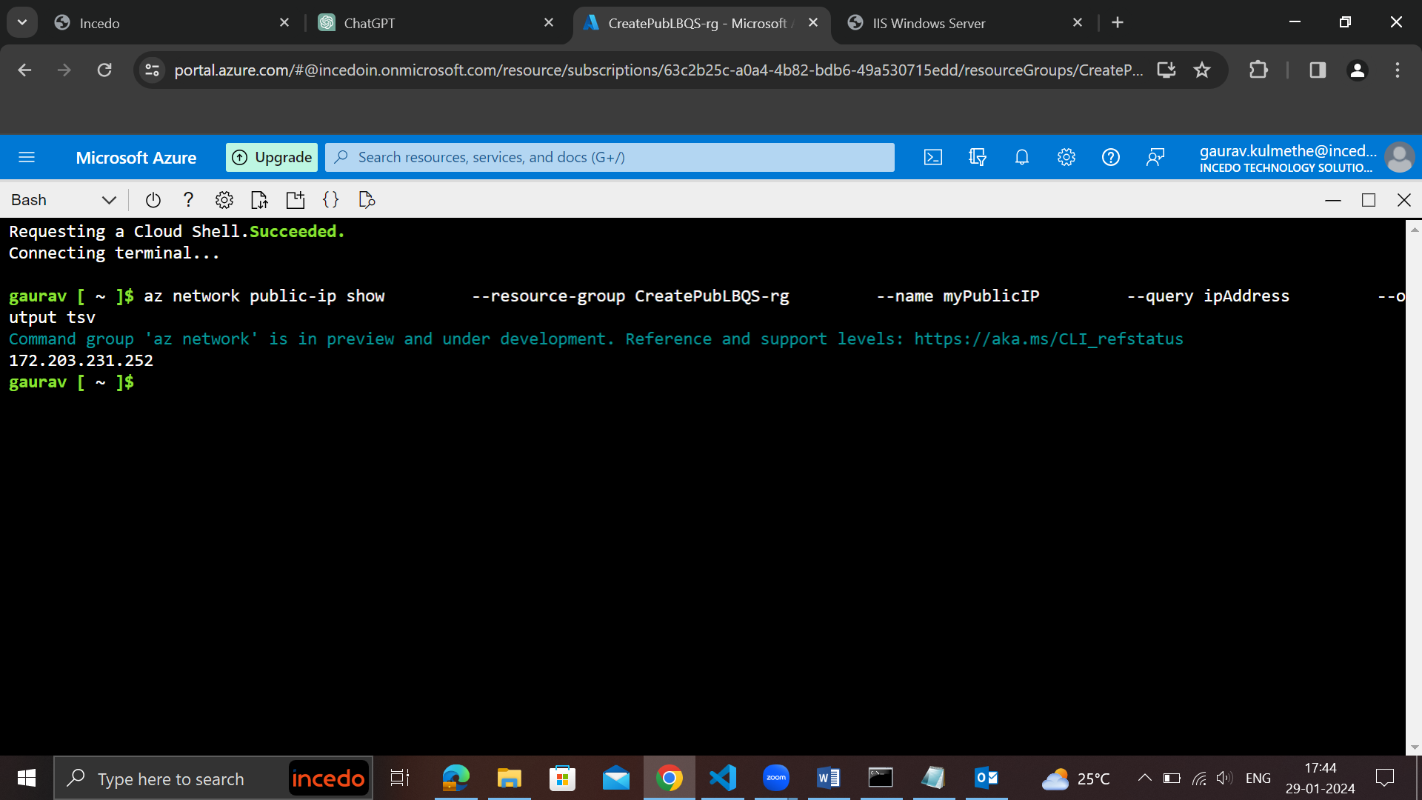

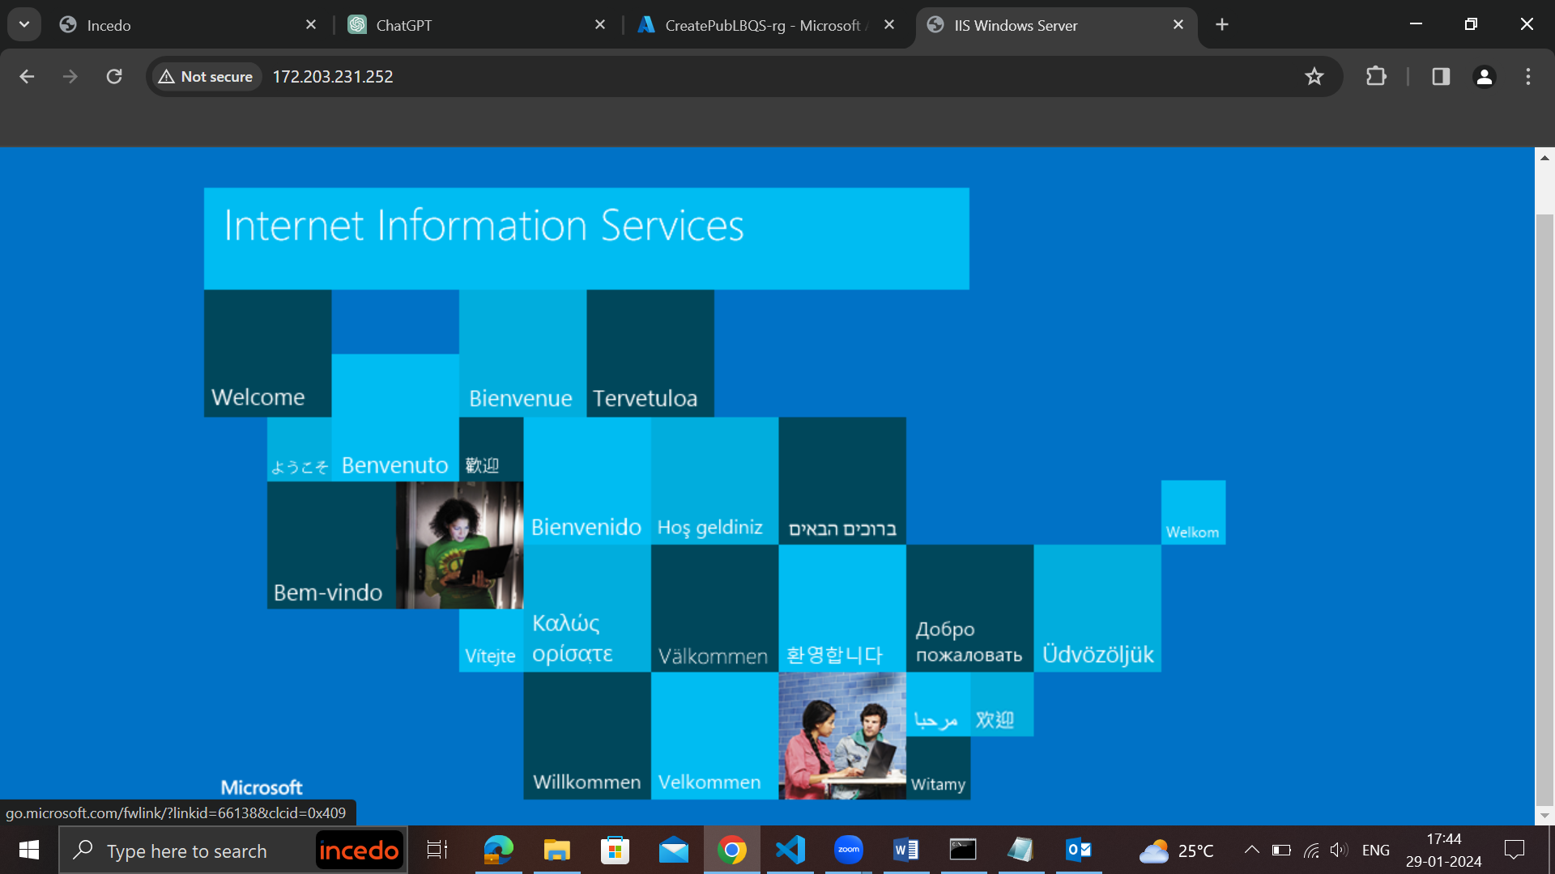

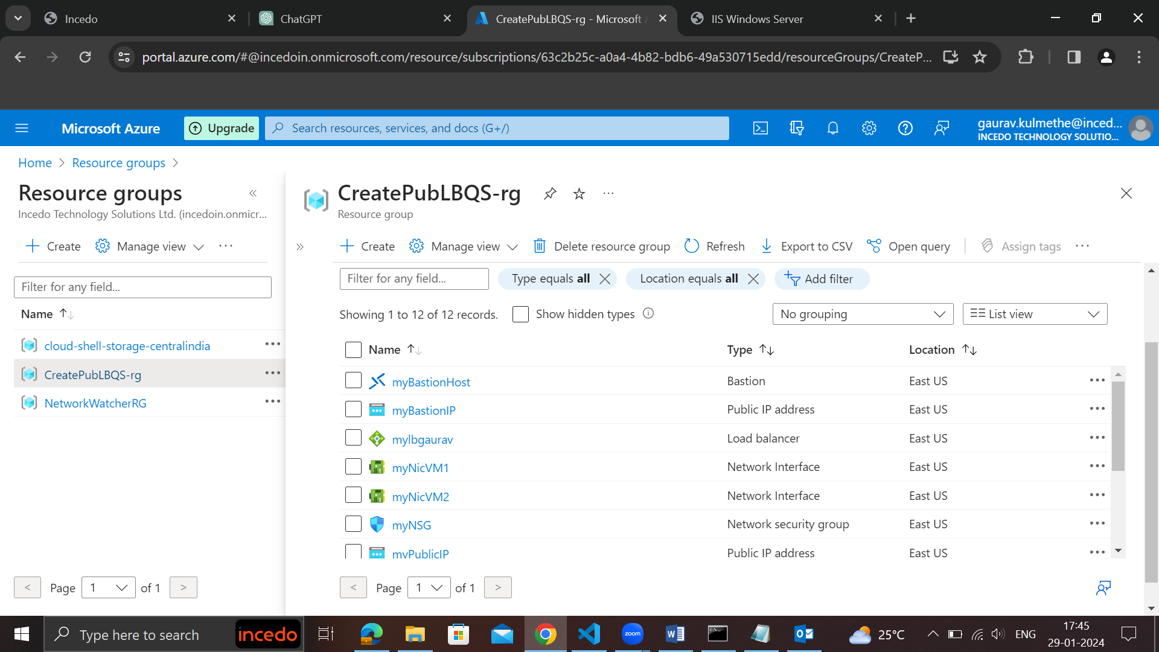

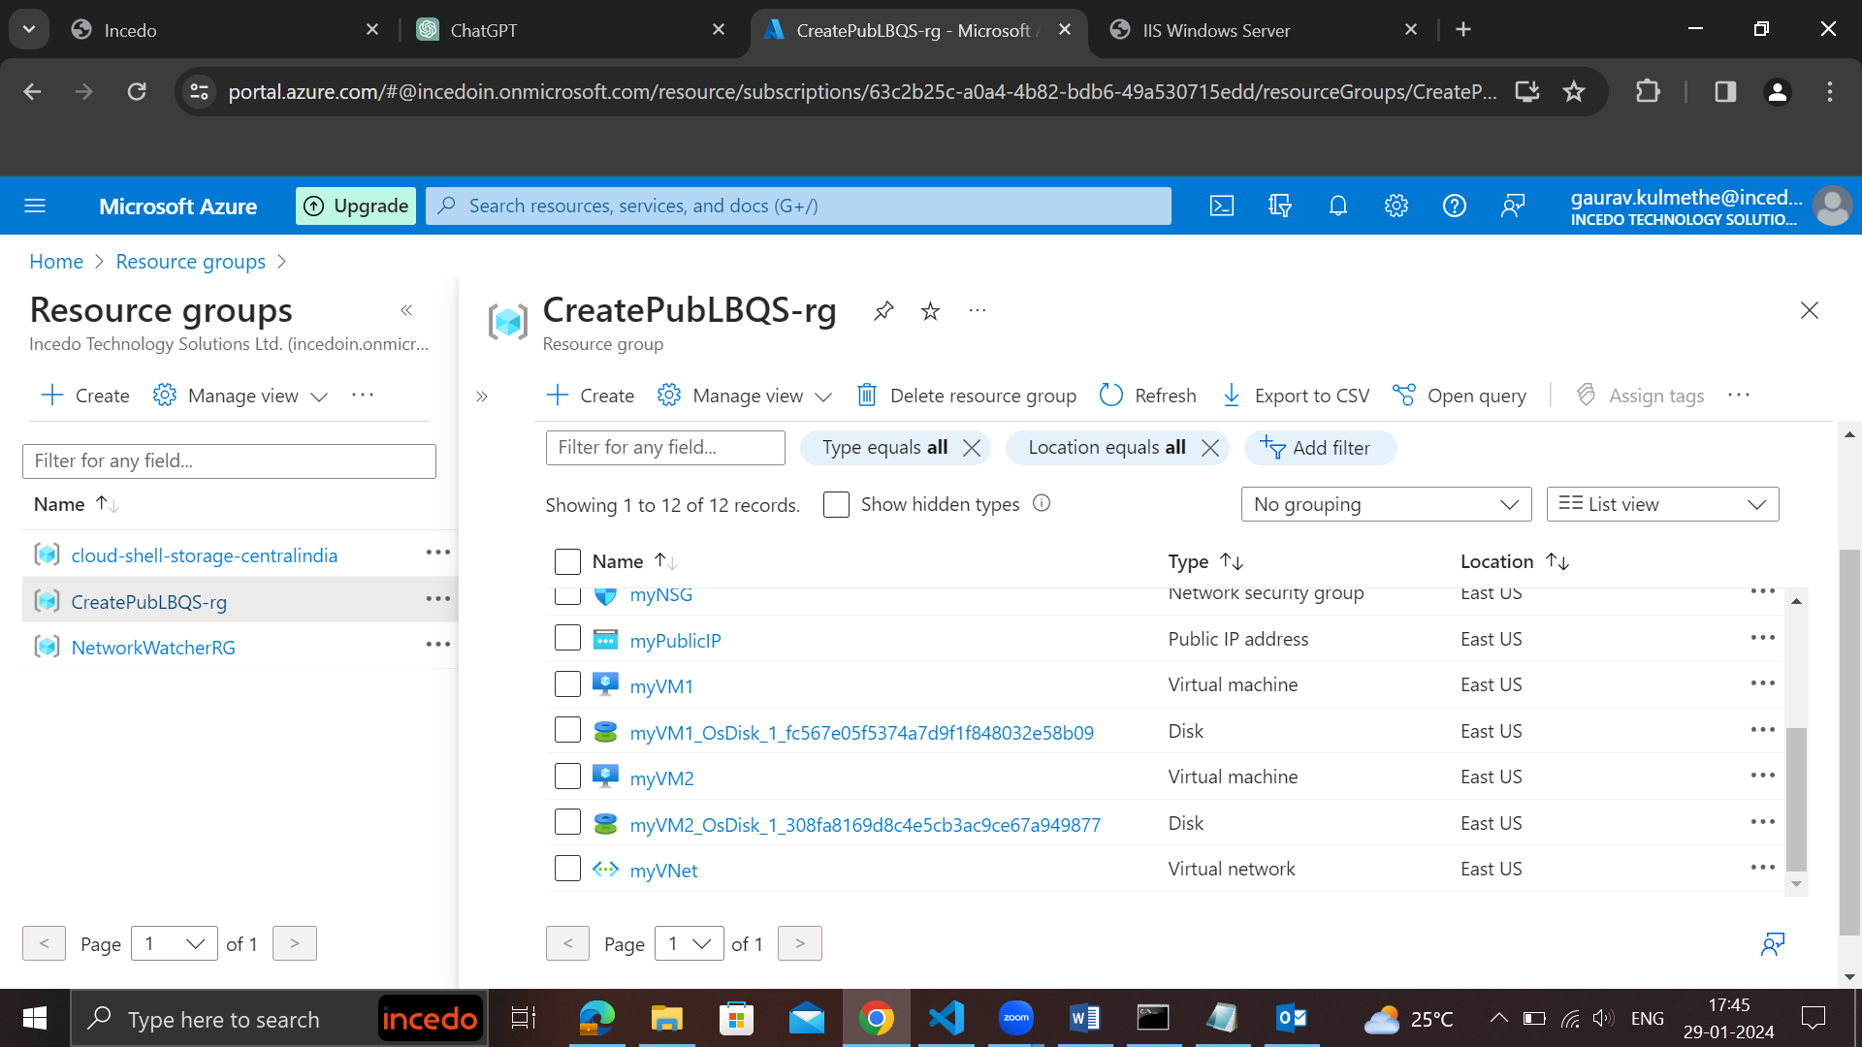

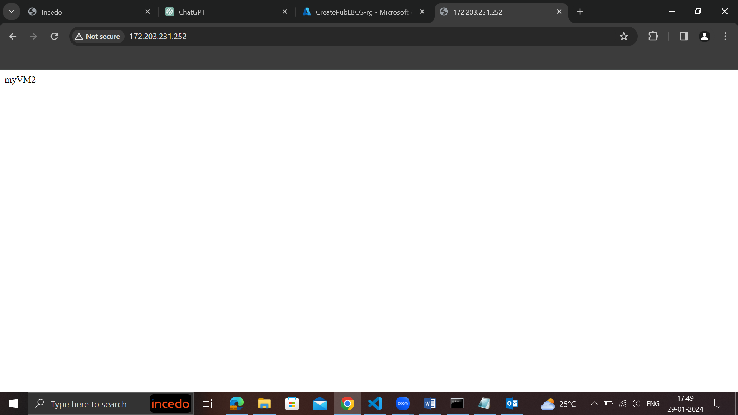

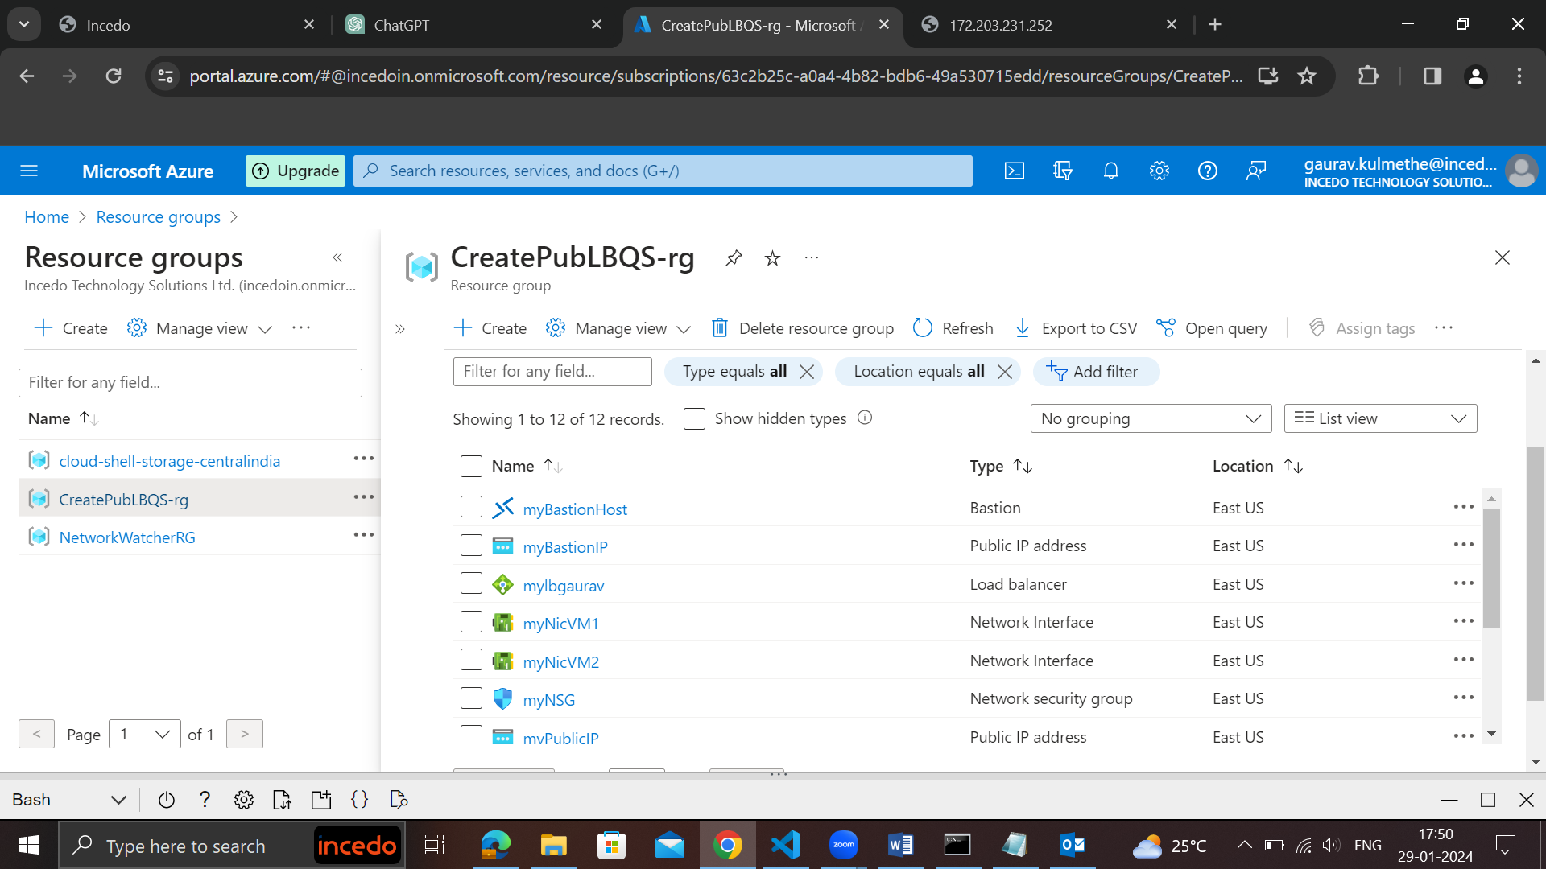

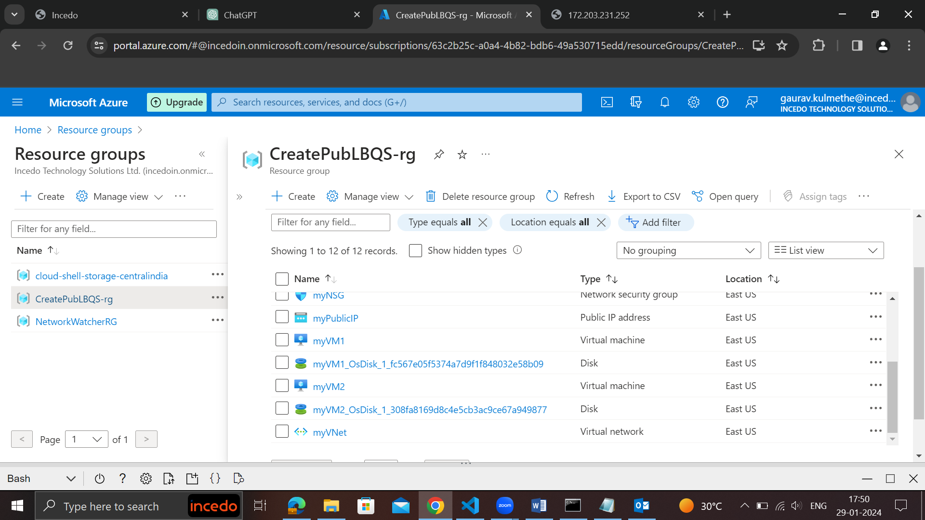

After stopping vm1

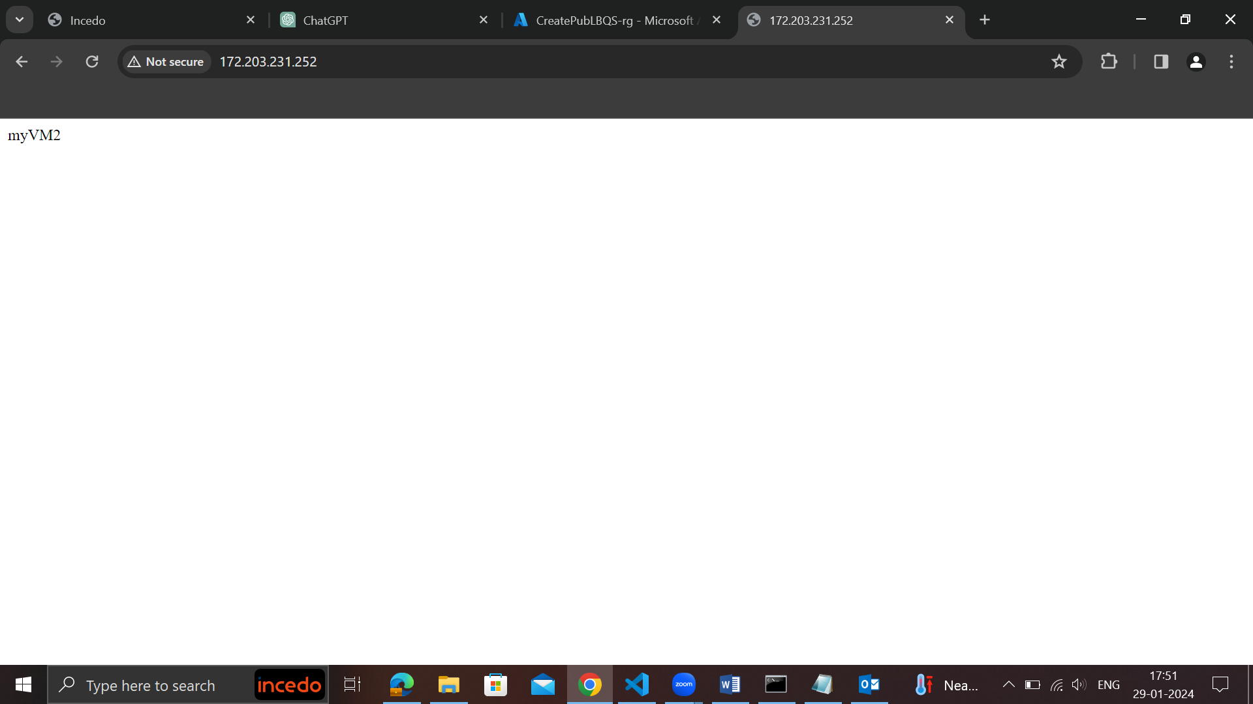

After stopping vm2

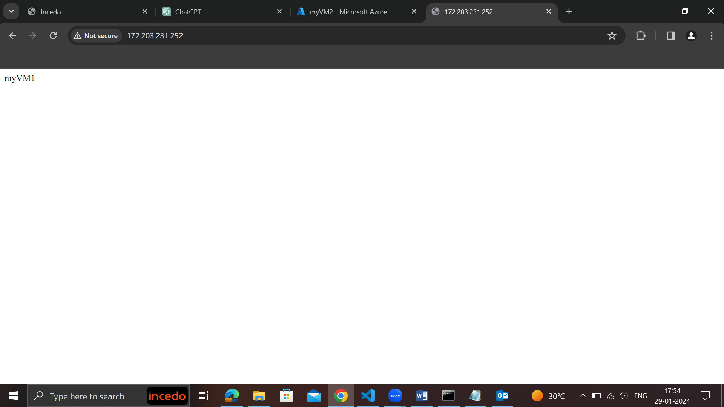

<https://github.com/NubeEra-Samples/AzureServices>

dated 30-01-2023

SAST  
for agile paid tool jira  
before jira, trello, integrate with version control system  
how to work with the treelo ,jira ticketing categoroy tools

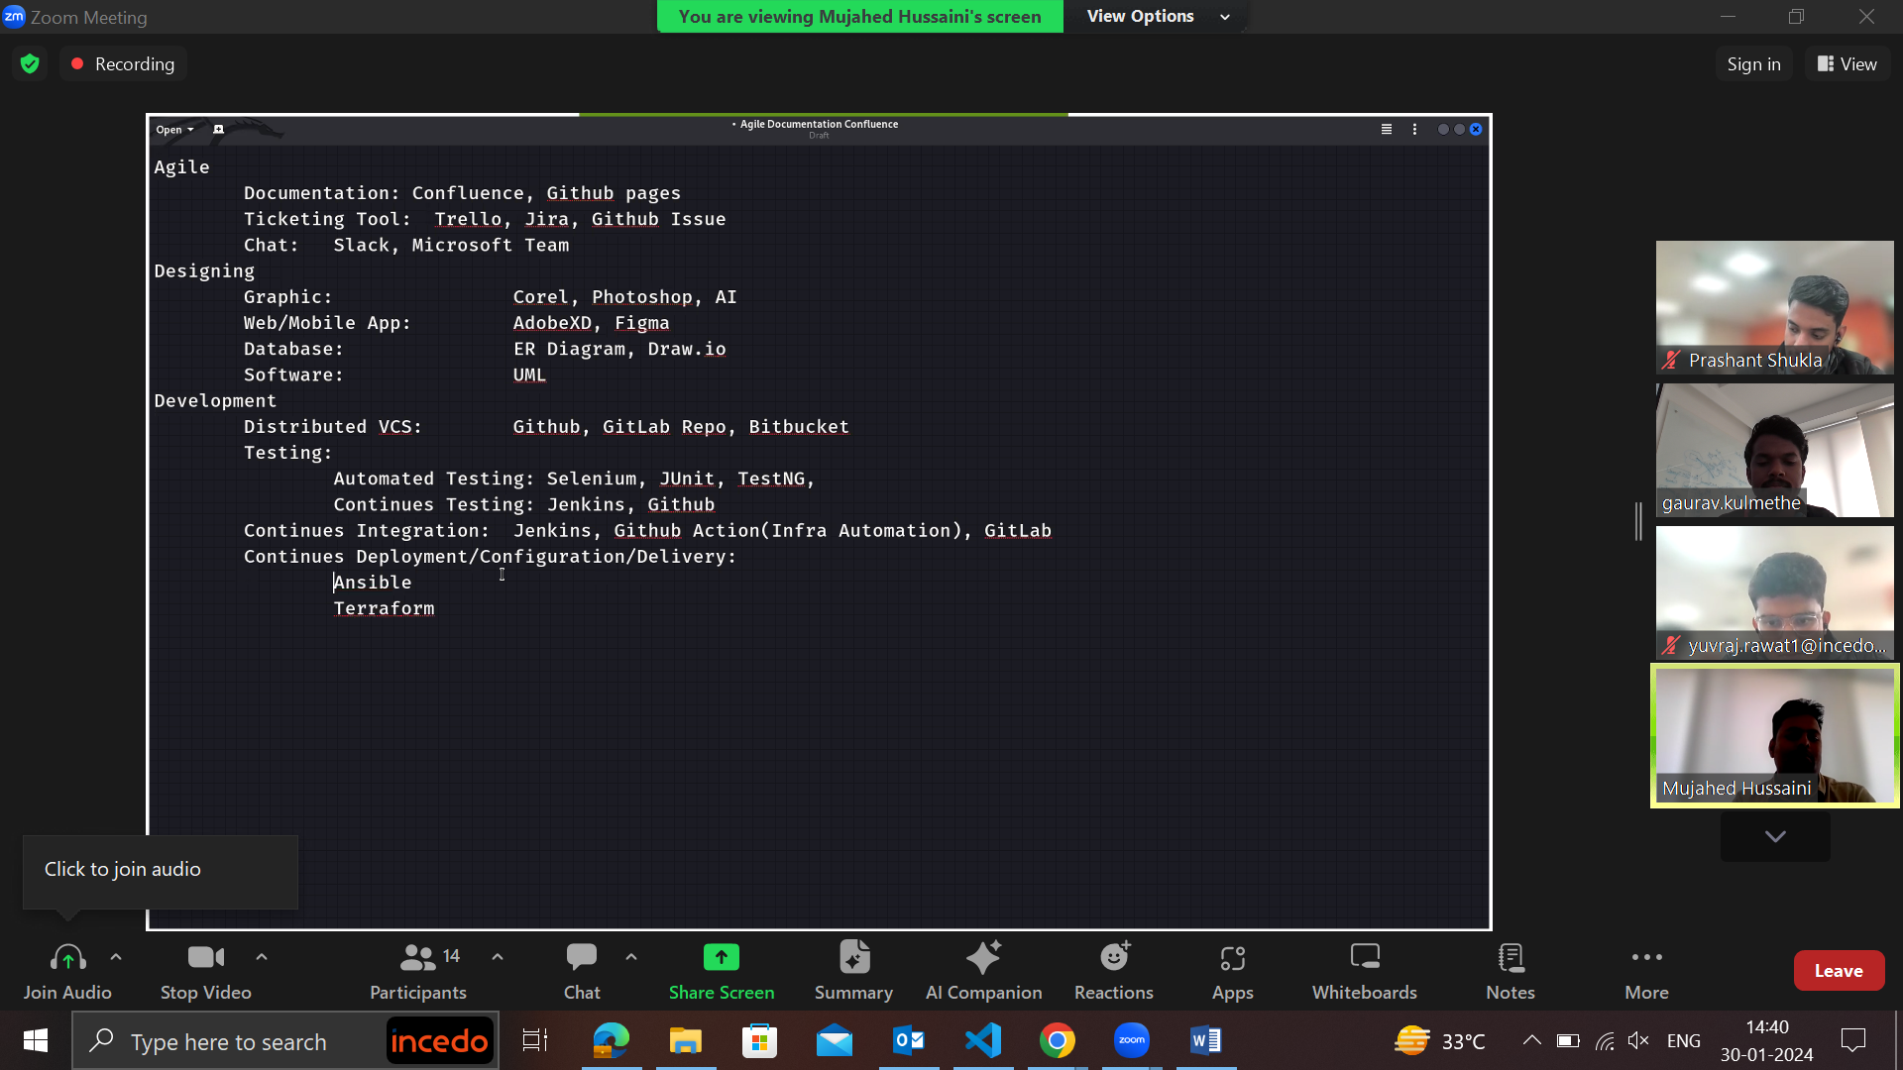

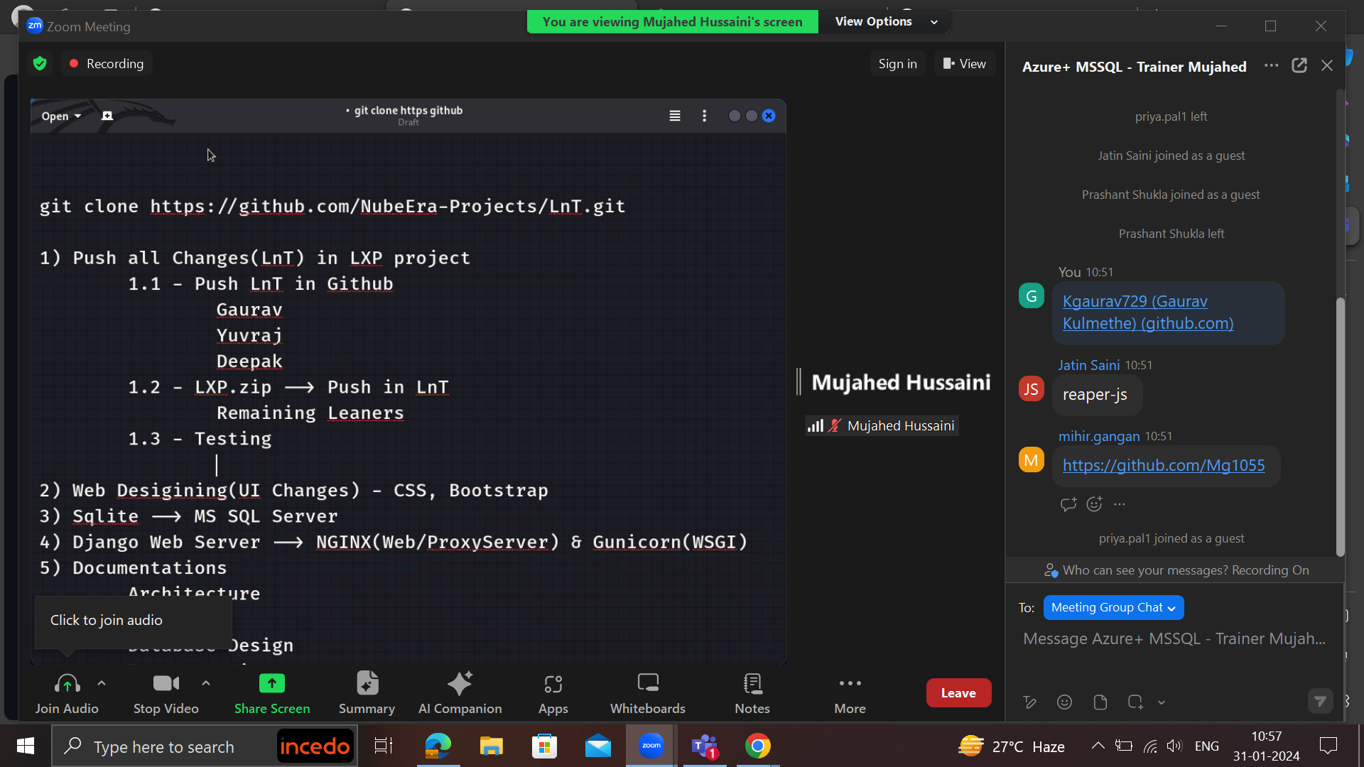

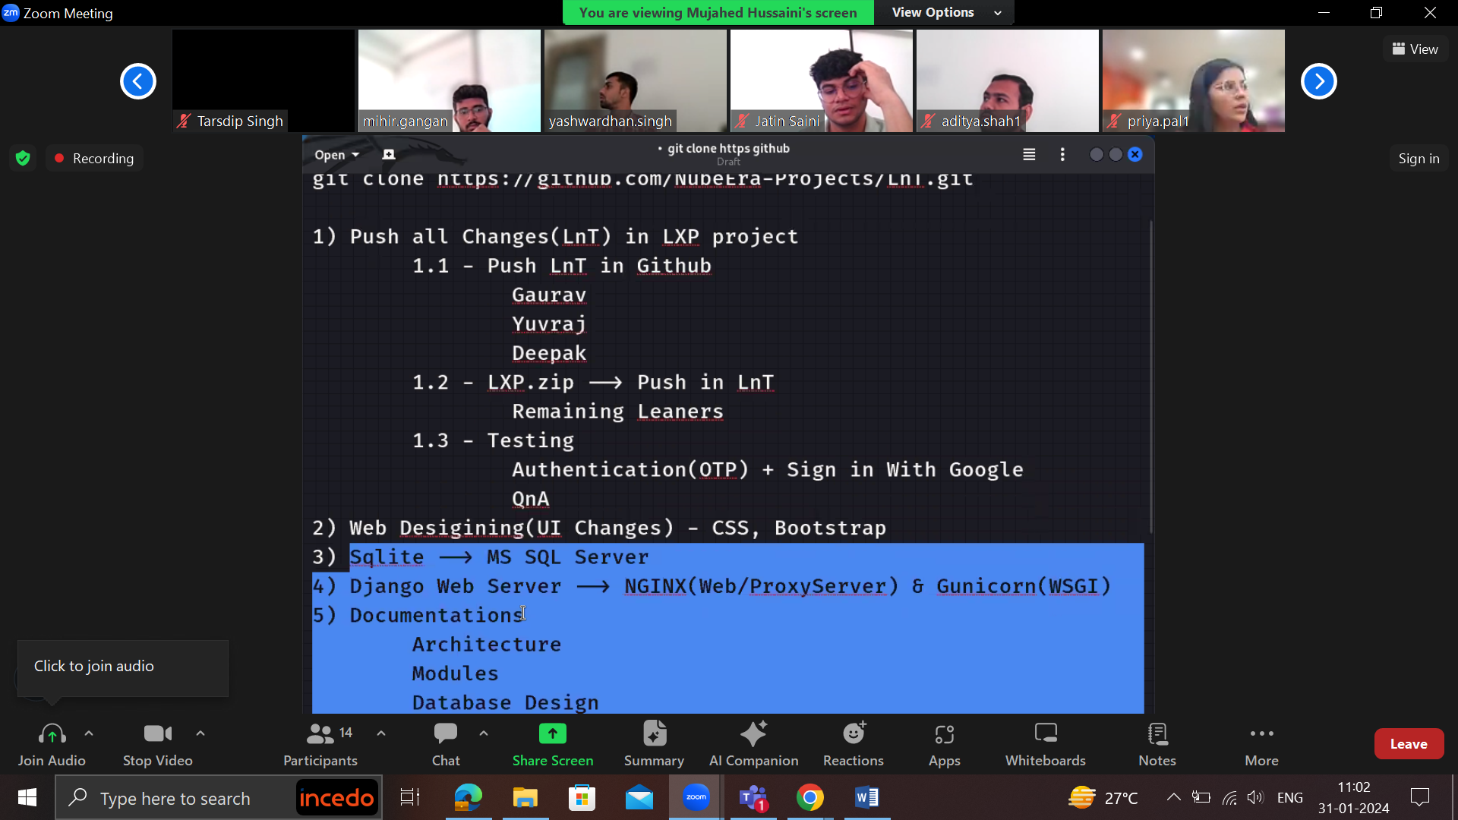

ETL 2feb 2024

Creating resource grp

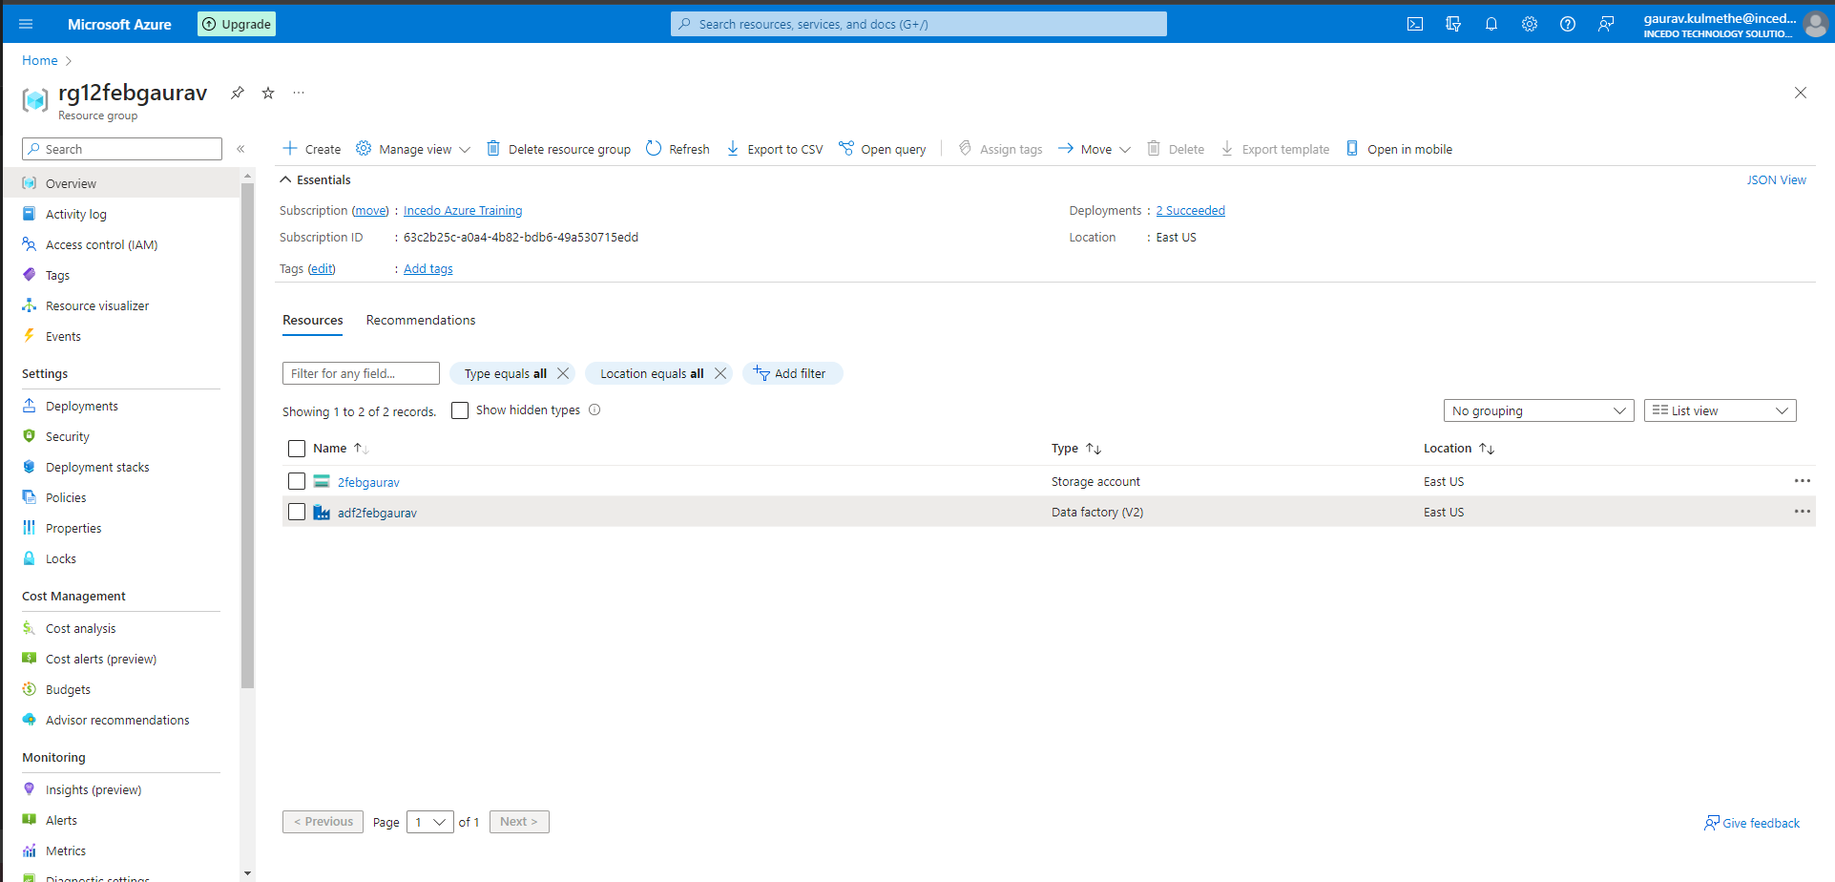

Creating storage accounts

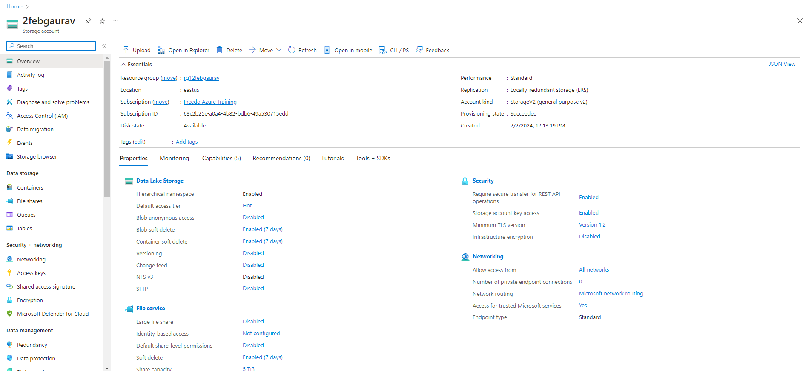

Creating containers

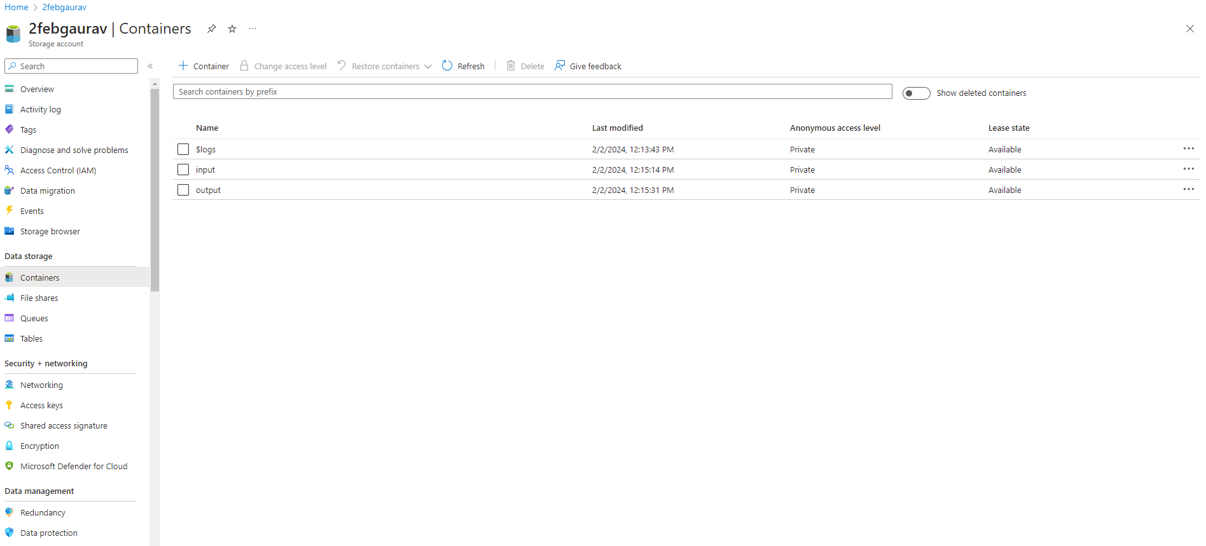

Input container

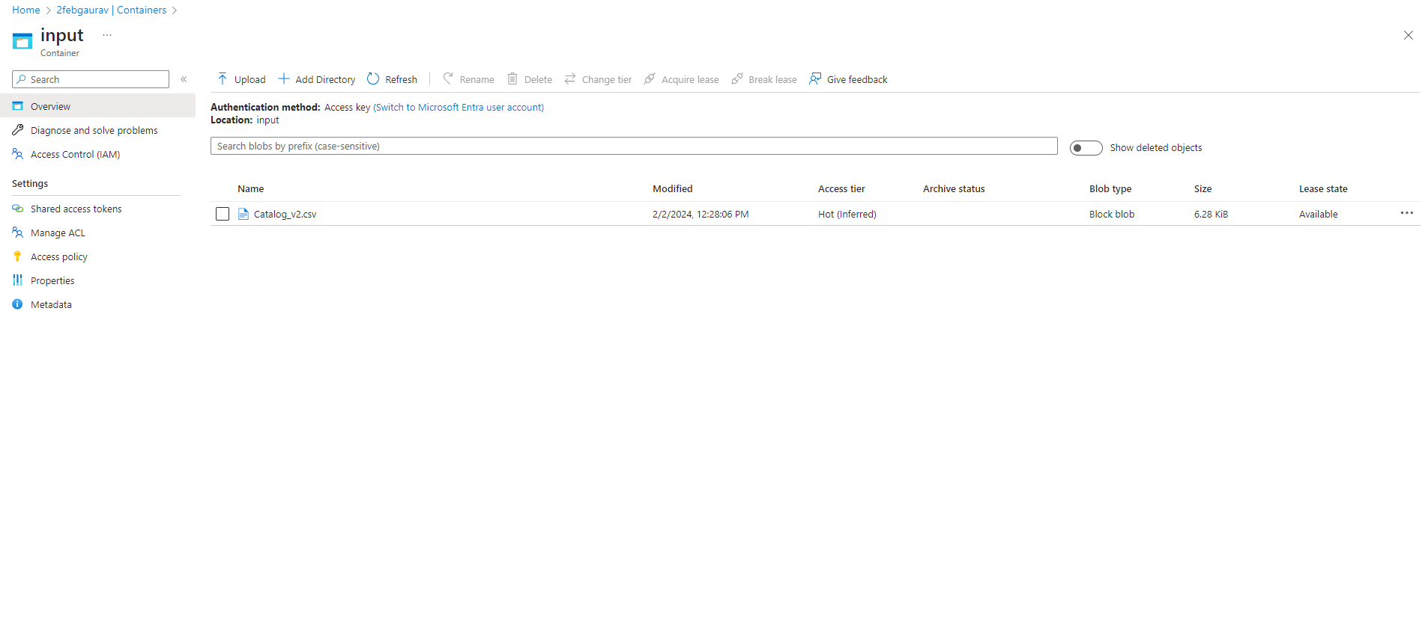

Data factory

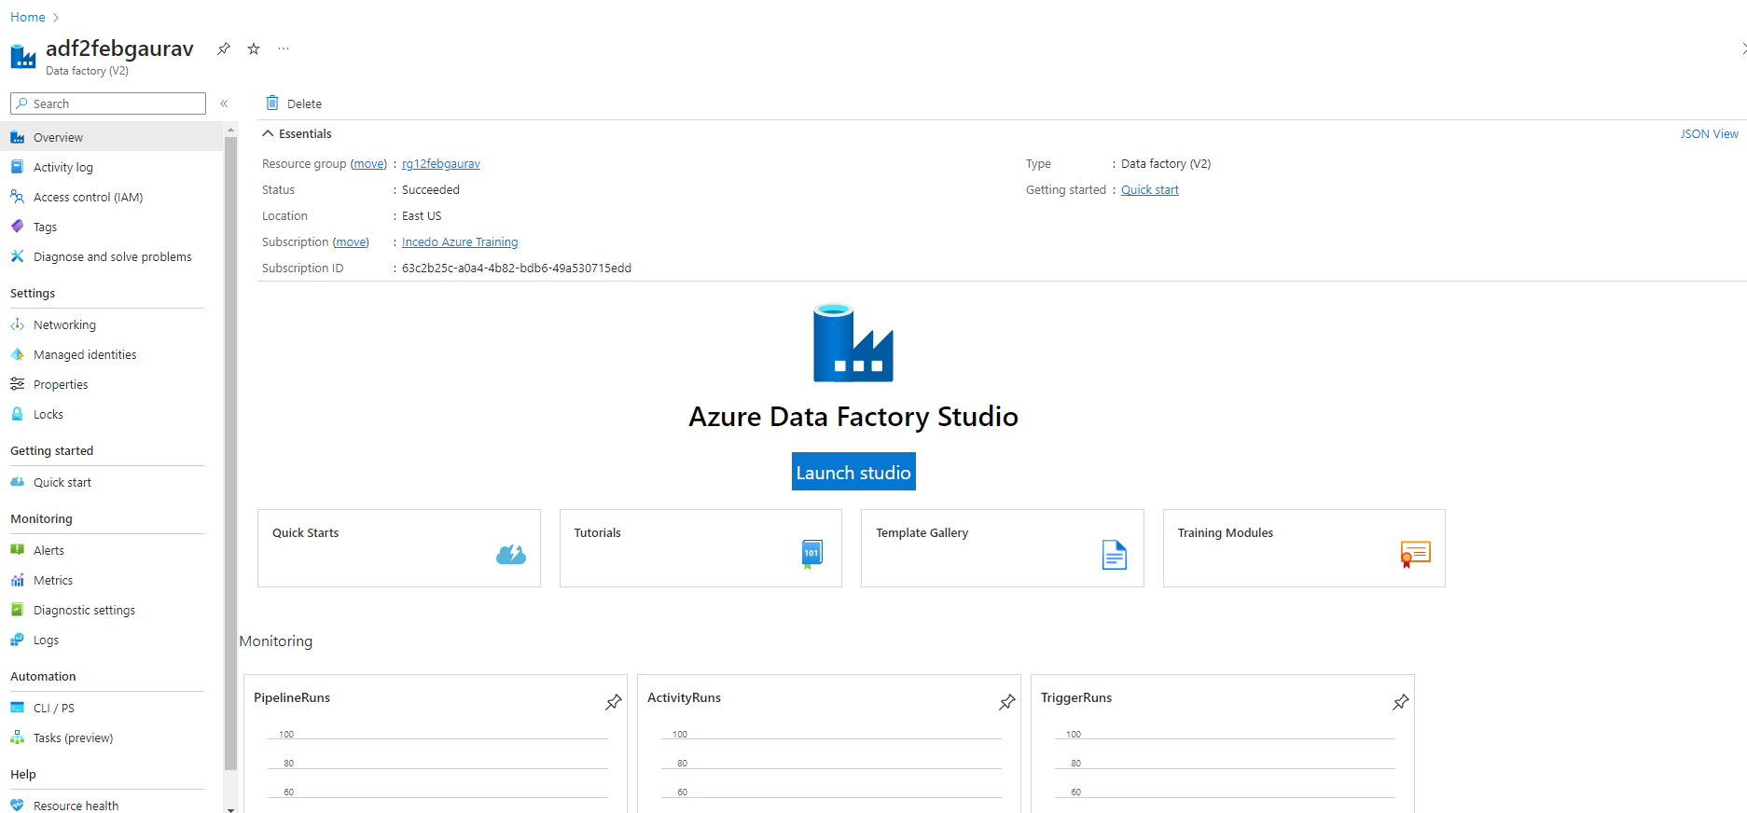

Linked service

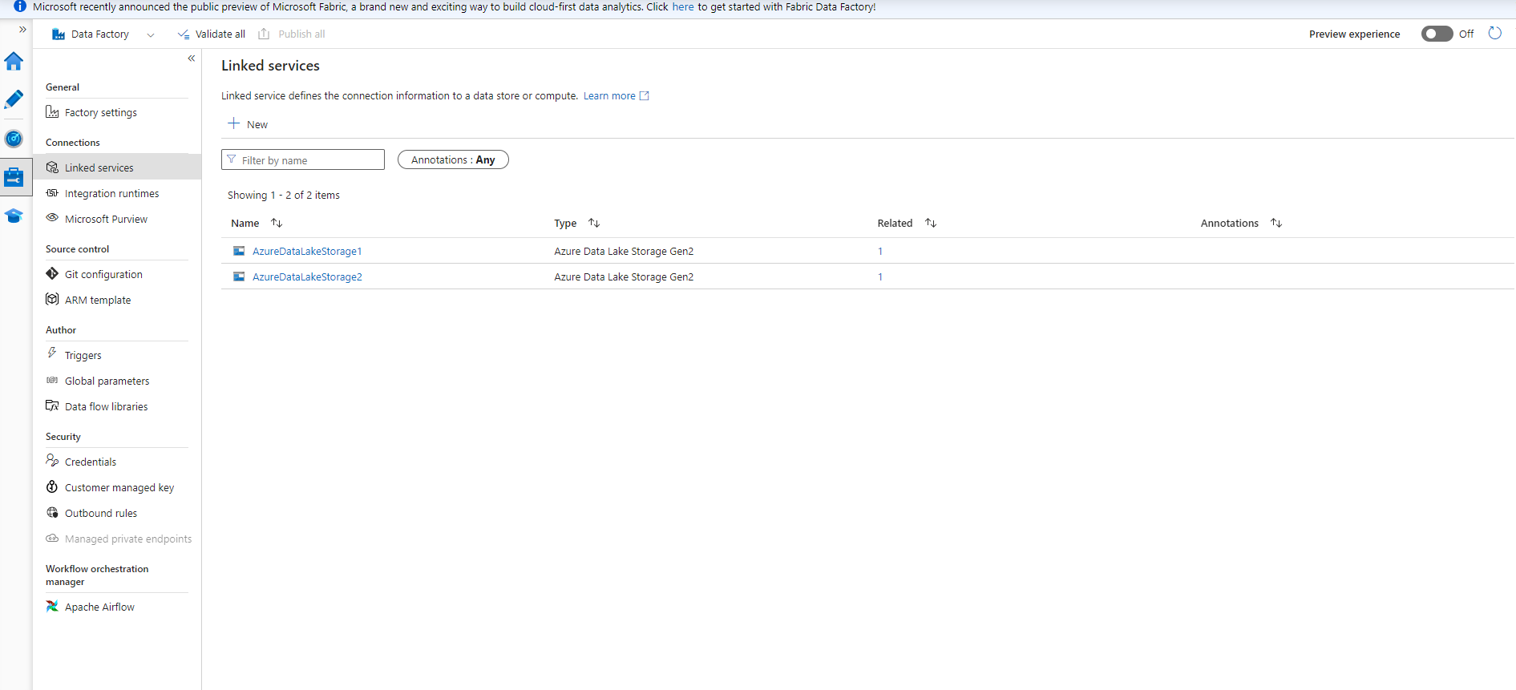

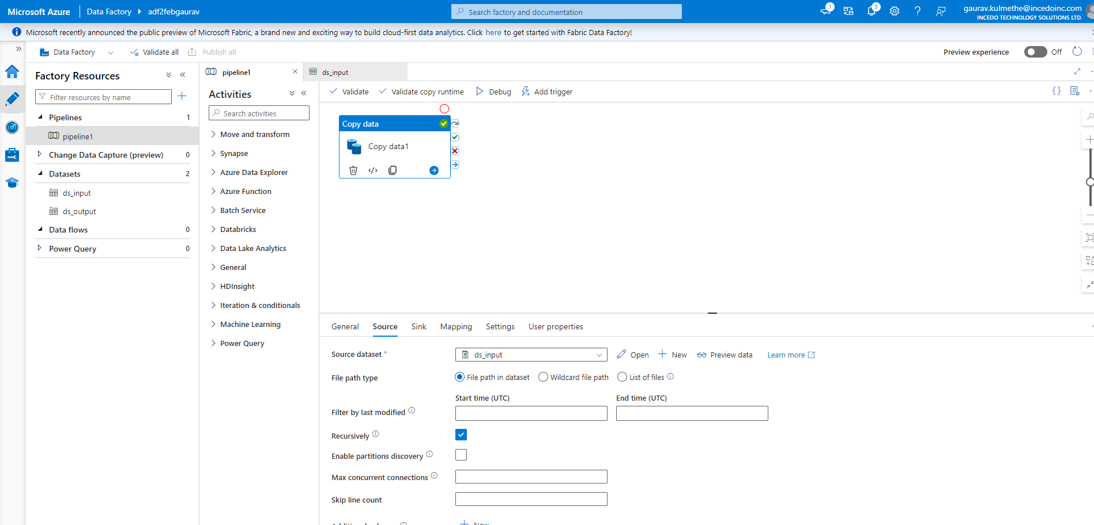

Sink path

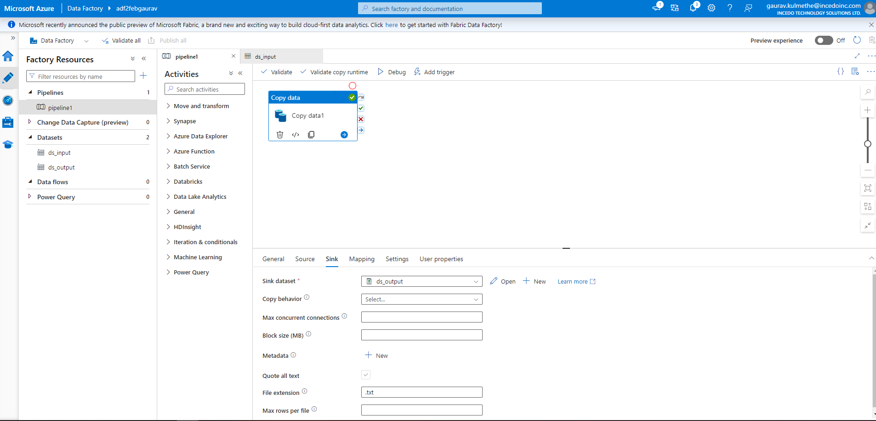

Dsinput

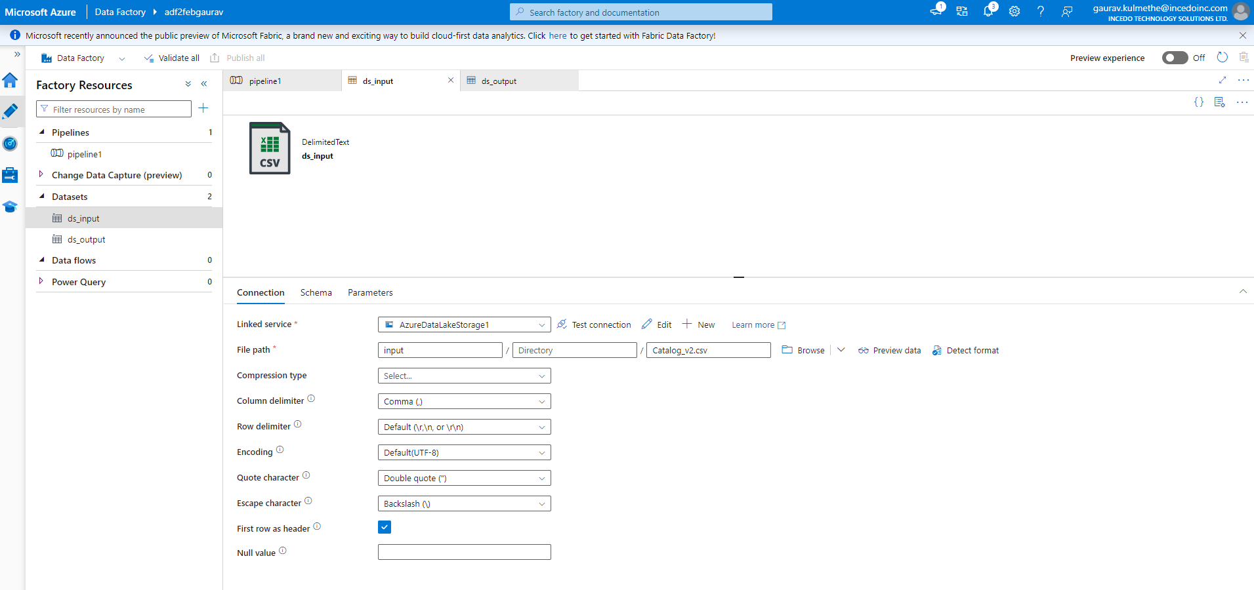

Dsoutput

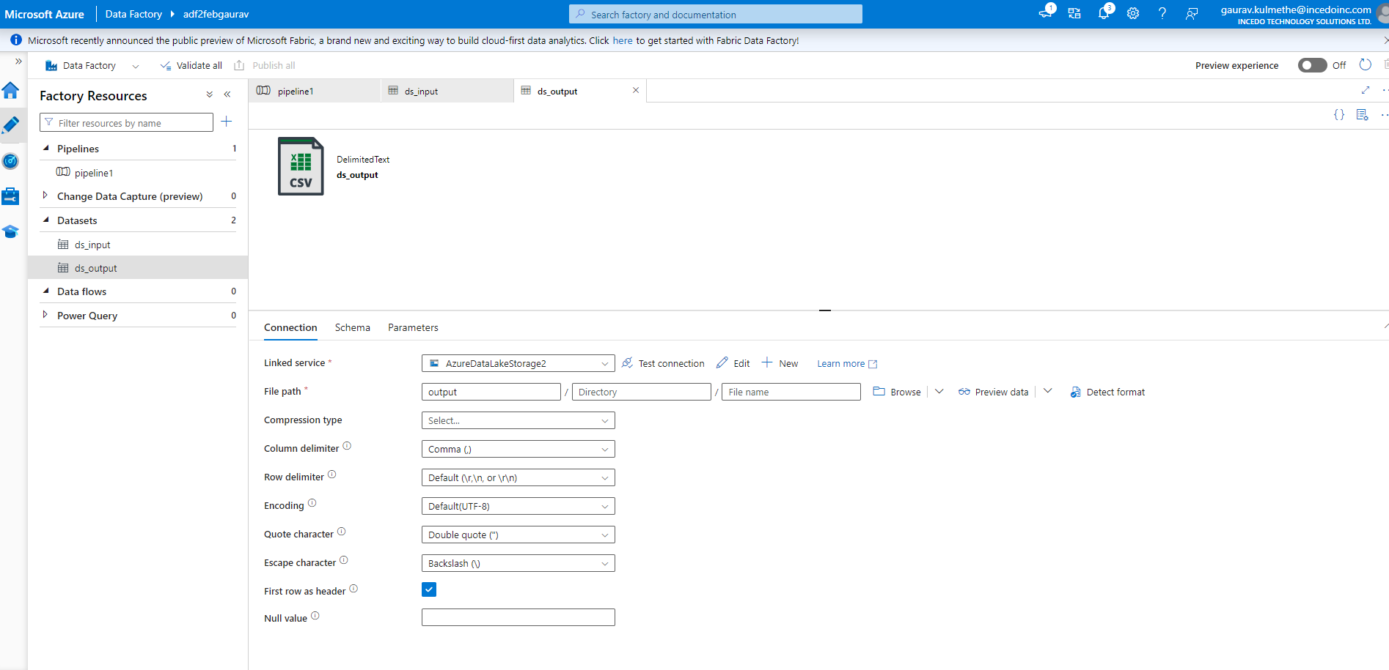

Output container

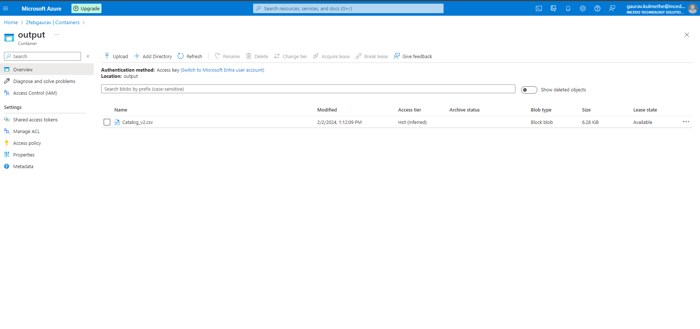

Sql database query

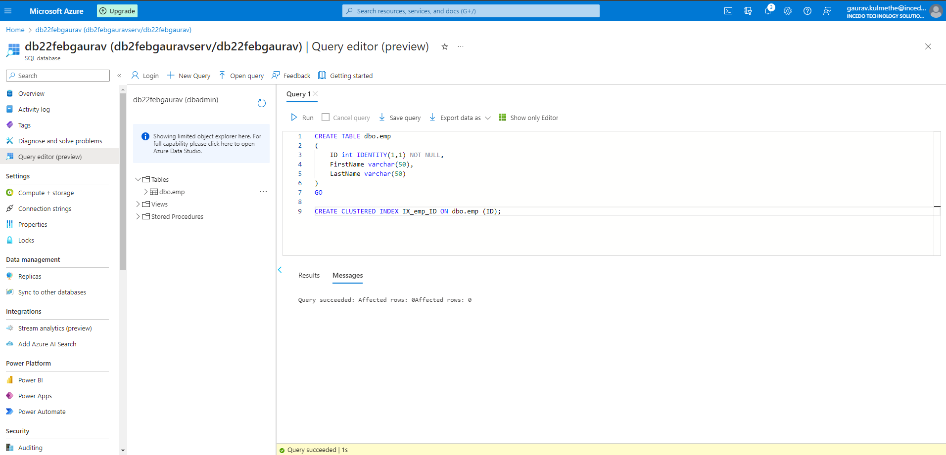

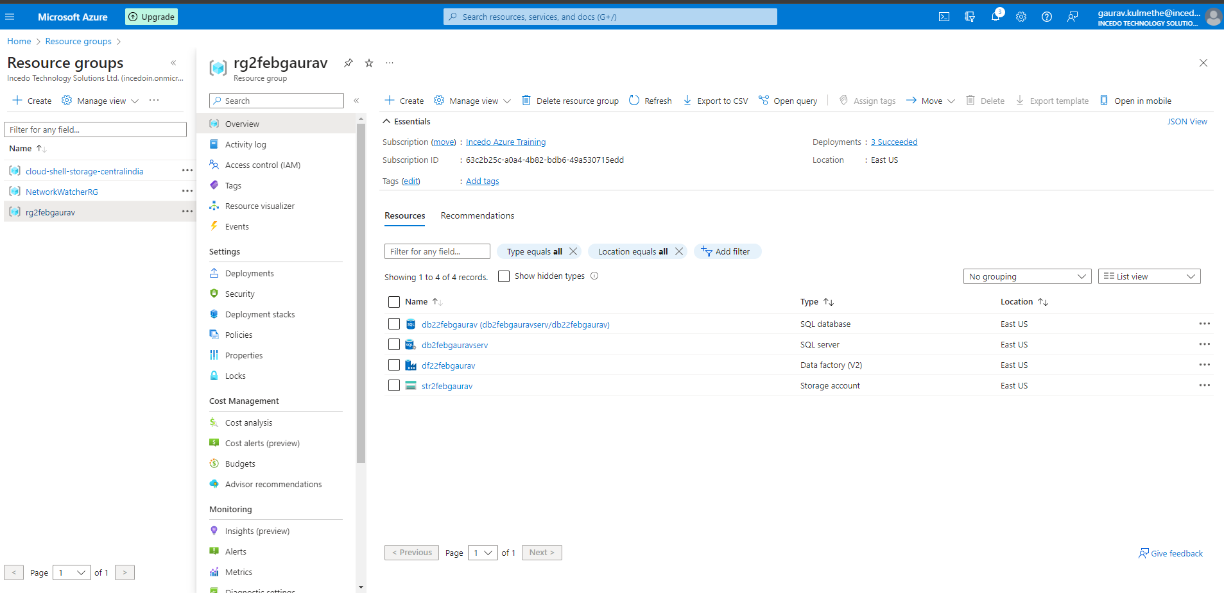

Storage account

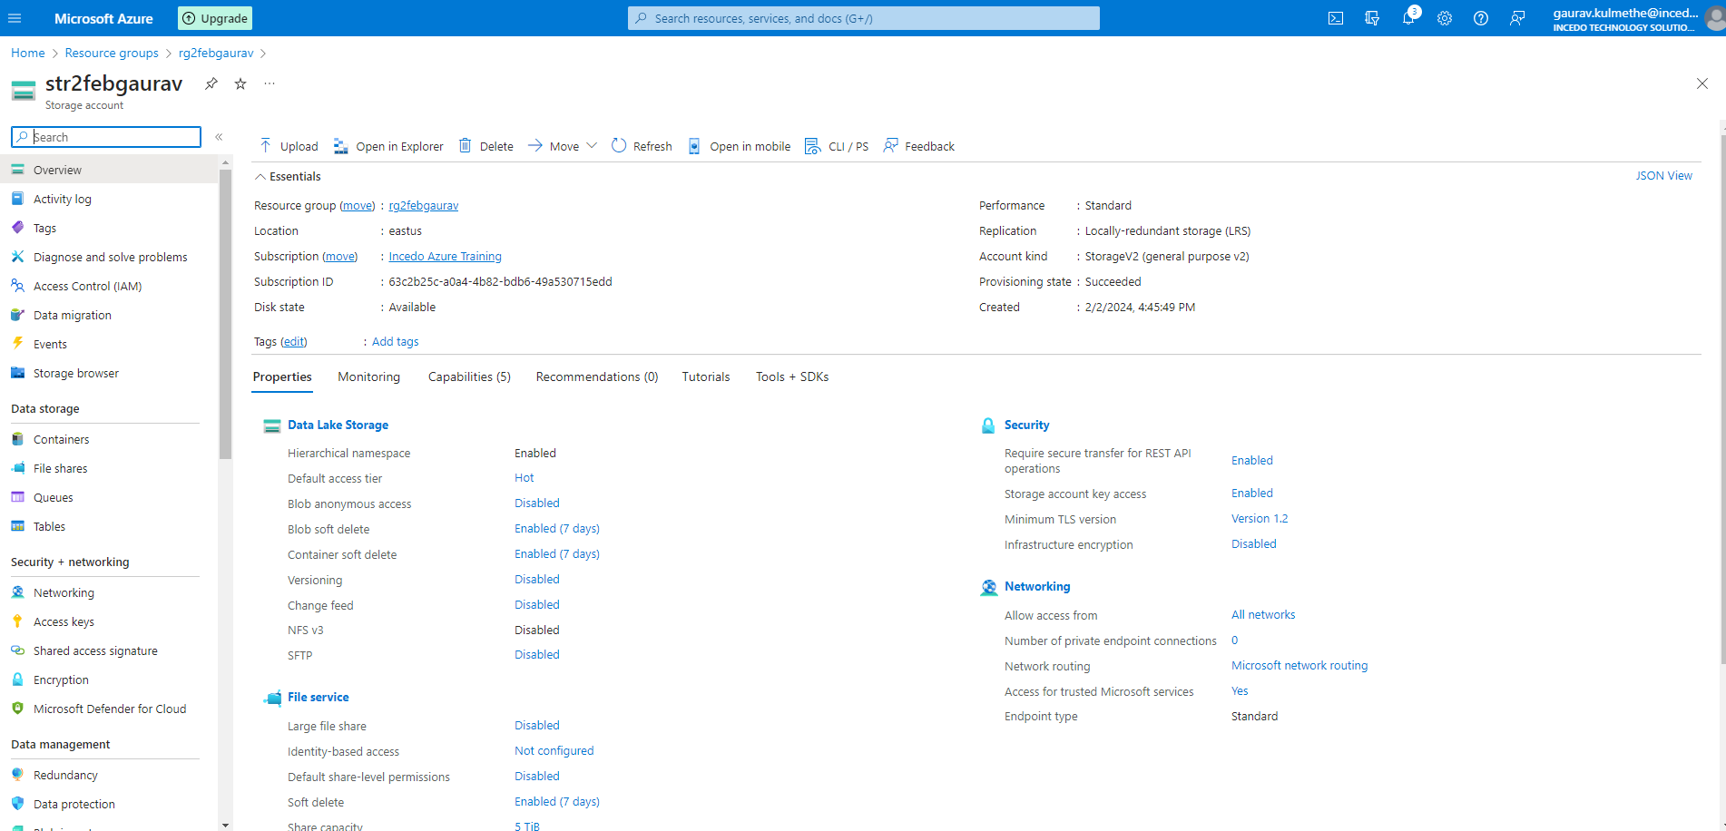

Database server

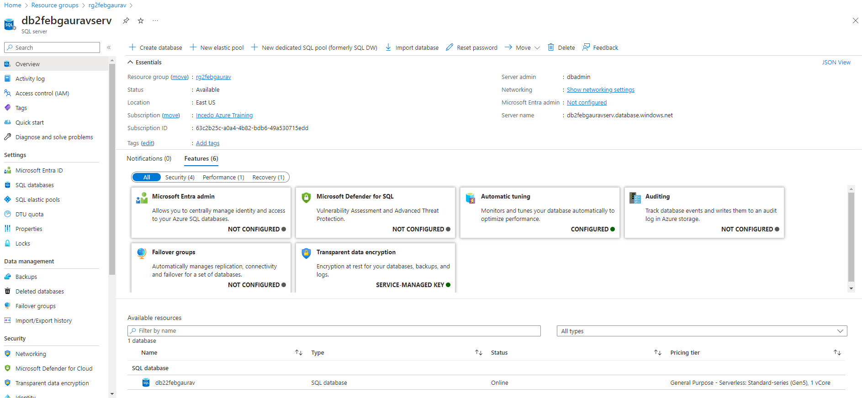

Database

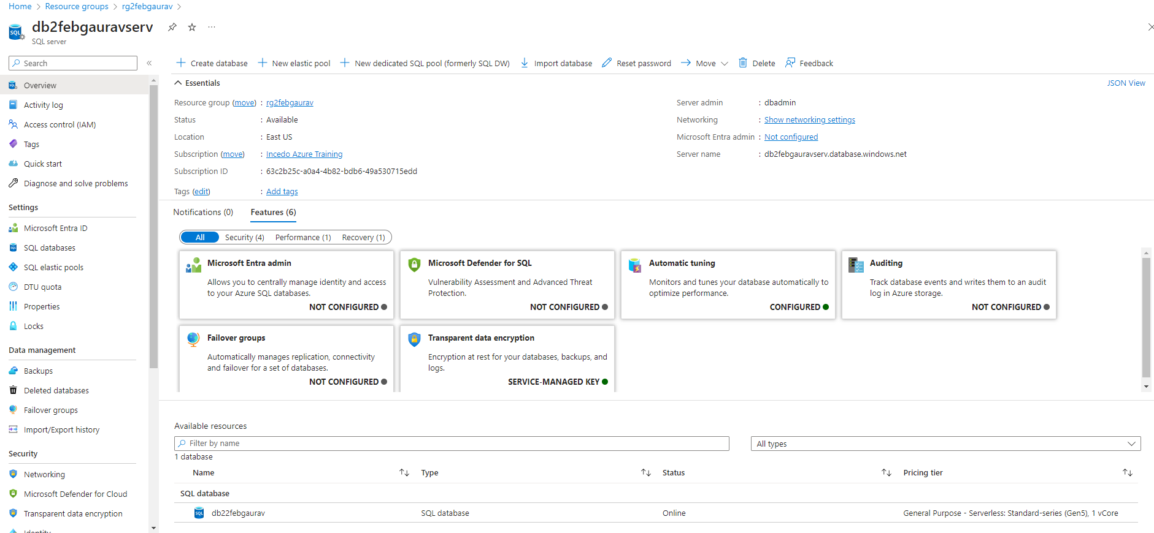

Datafactory dashboard

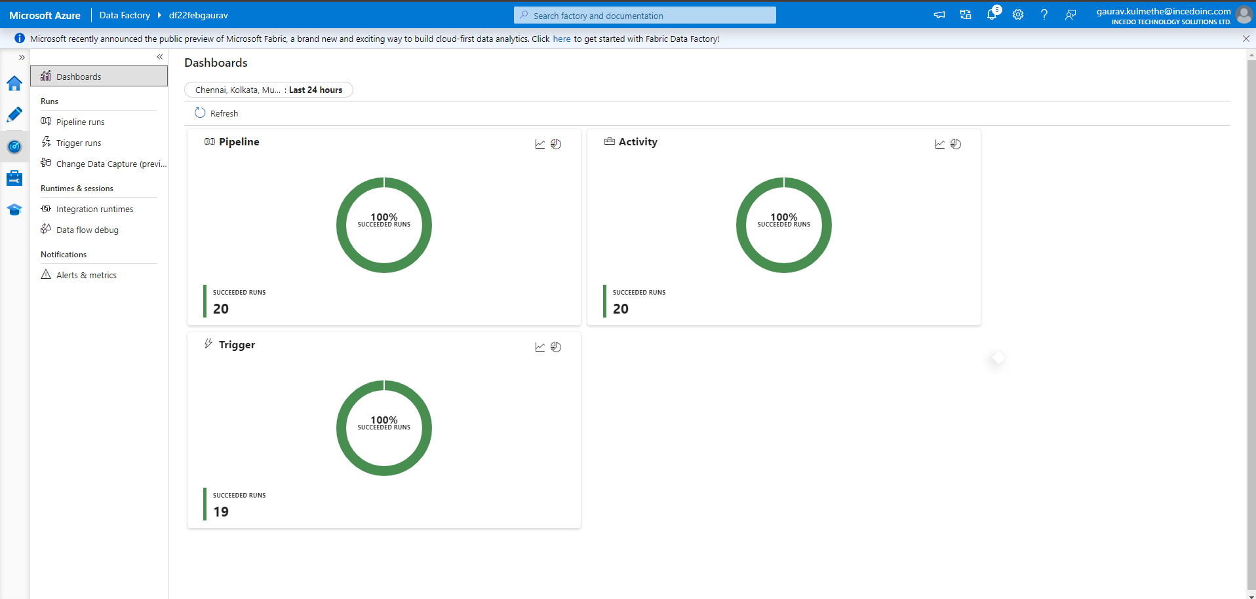

Triggered runs

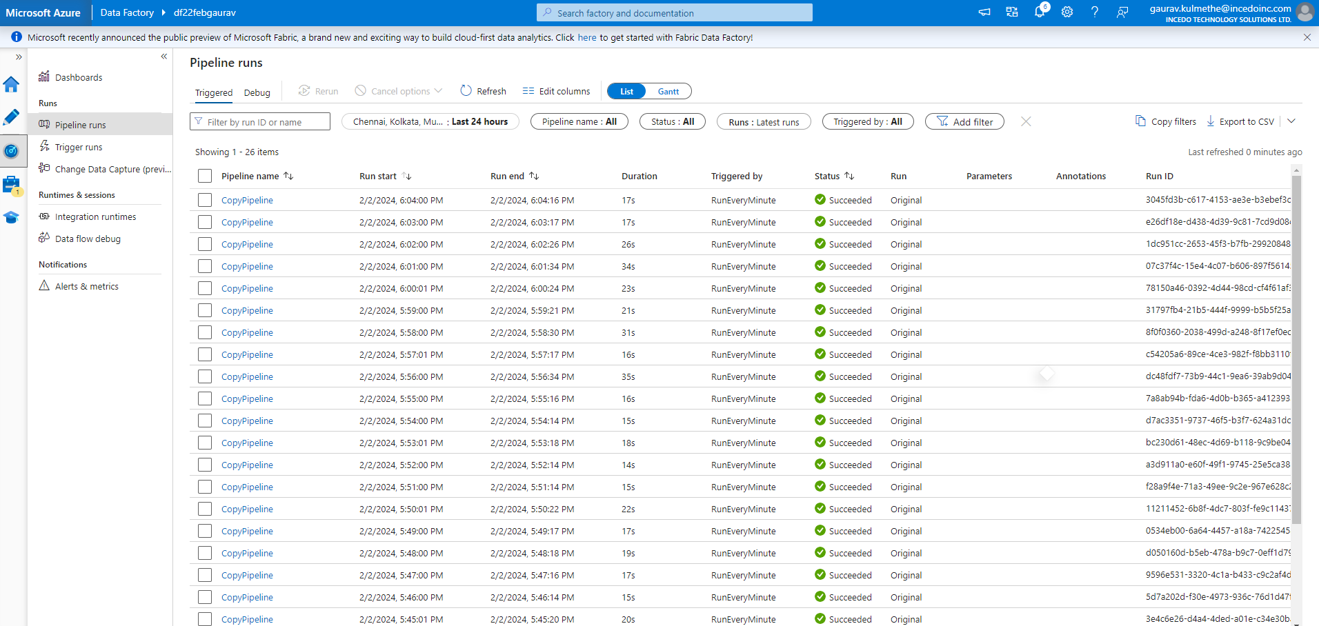

Debug

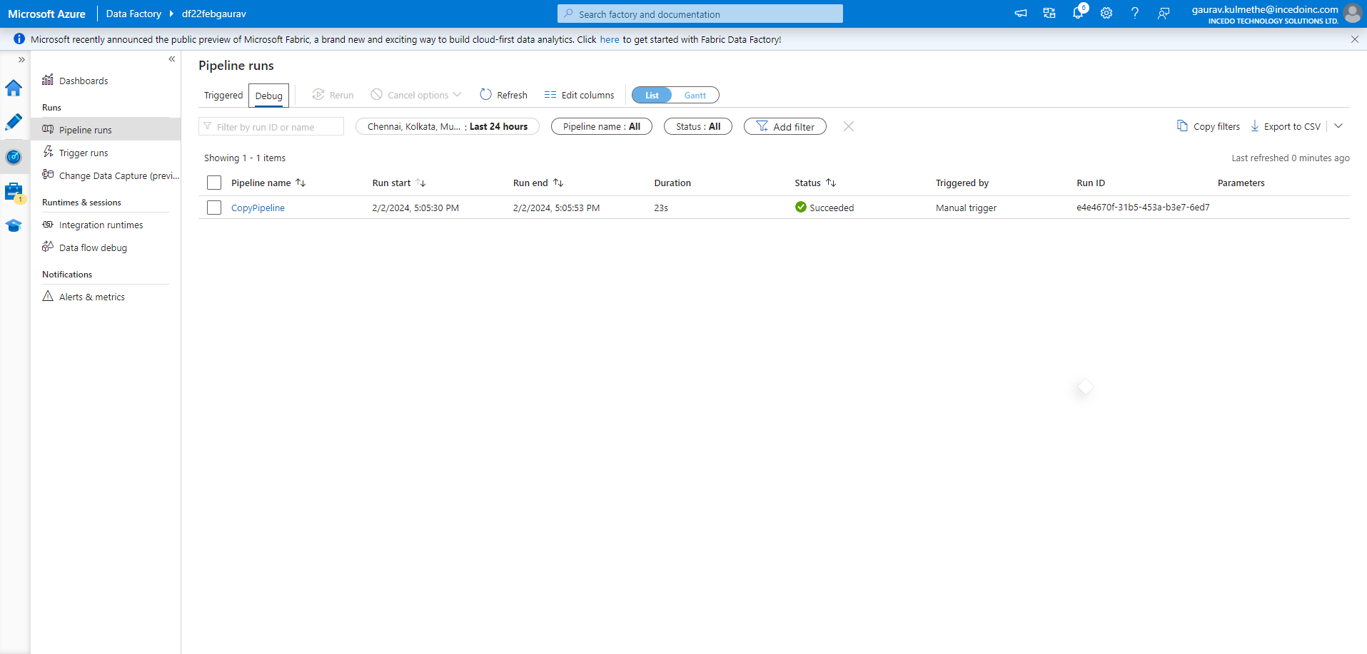

Linked services

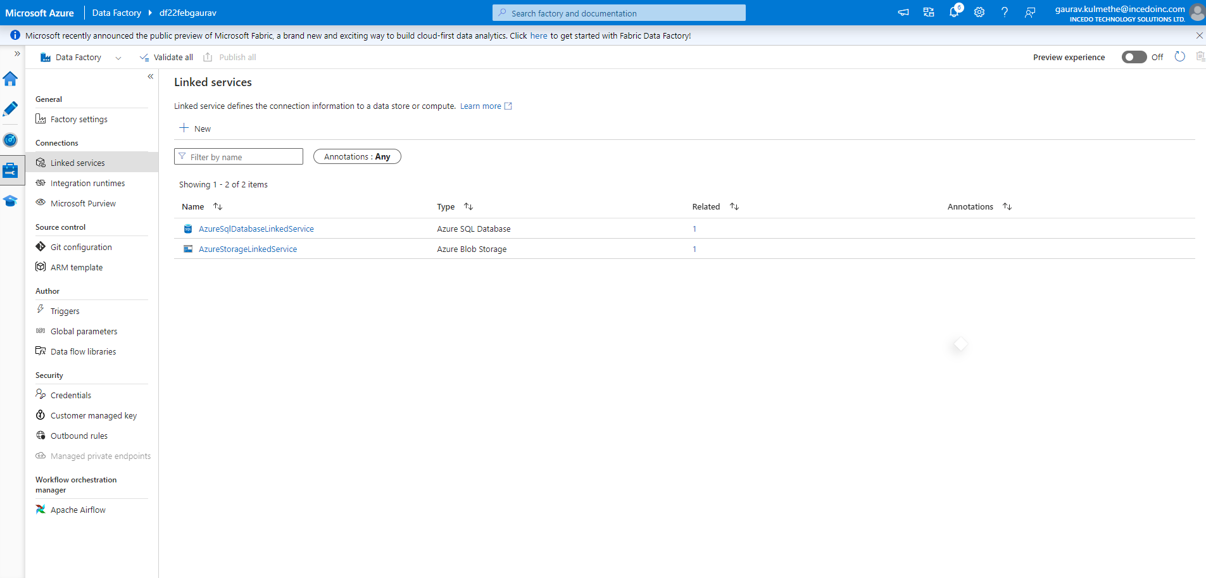

Output SQL Dataset

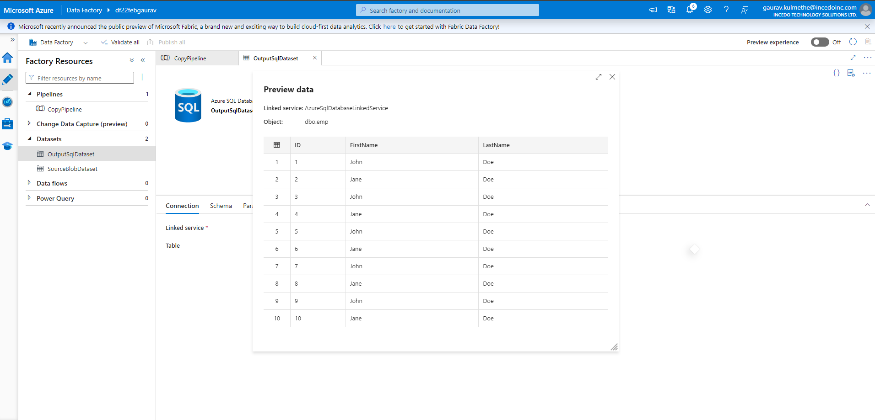

Sourceblobdatasets

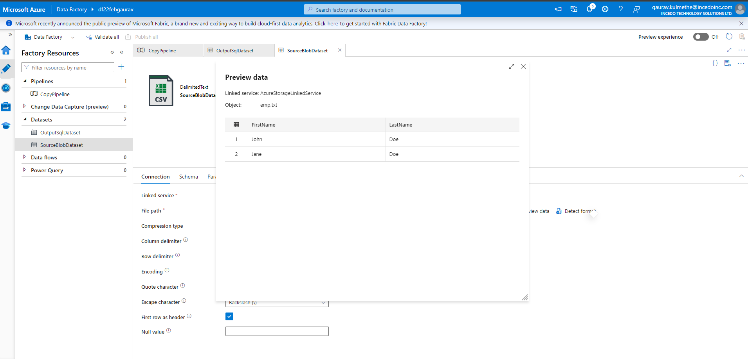

Vnet to Vnet Connection dt.04-02-2024

